R Notebook

John Kamau

21/08/2019

# Q6 Did the meeting start late?

|  |  |  |  |  |  |  |
| --- | --- | --- | --- | --- | --- | --- |
| Late | Mali_1 | Mali_2 | Mali_3 | Uganda_1 | Uganda_2 | Uganda_3 |
| Yes | 86 | 76 | 58 | 81 | 84 | 79 |
| No | 66 | 76 | 94 | 60 | 59 | 57 |
| Respondents | 152 | 152 | 152 | 141 | 143 | 136 |

|  |  |  |  |  |  |  |
| --- | --- | --- | --- | --- | --- | --- |
| Late | Mali_1 | Mali_2 | Mali_3 | Uganda_1 | Uganda_2 | Uganda_3 |
| Yes | 0.565789473684211 | 0.5 | 0.381578947368421 | 0.574468085106383 | 0.587412587412587 | 0.580882352941177 |
| No | 0.434210526315789 | 0.5 | 0.618421052631579 | 0.425531914893617 | 0.412587412587413 | 0.419117647058824 |
| Percentage | 1 | 1 | 1 | 1 | 1 | 1 |

# Q7 How many minutes too late did the meeting start?

## [1] "G1"

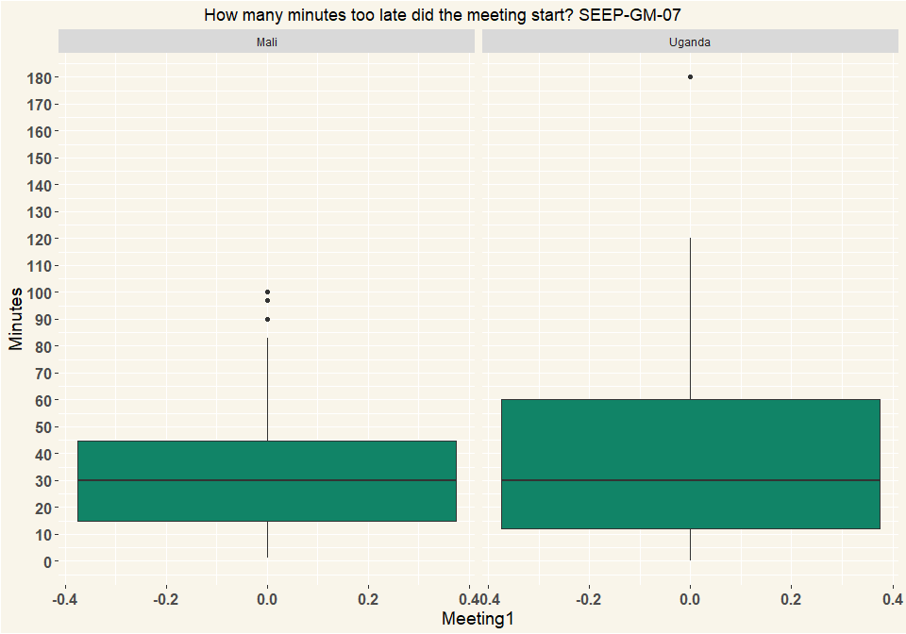

## [1] "G2"

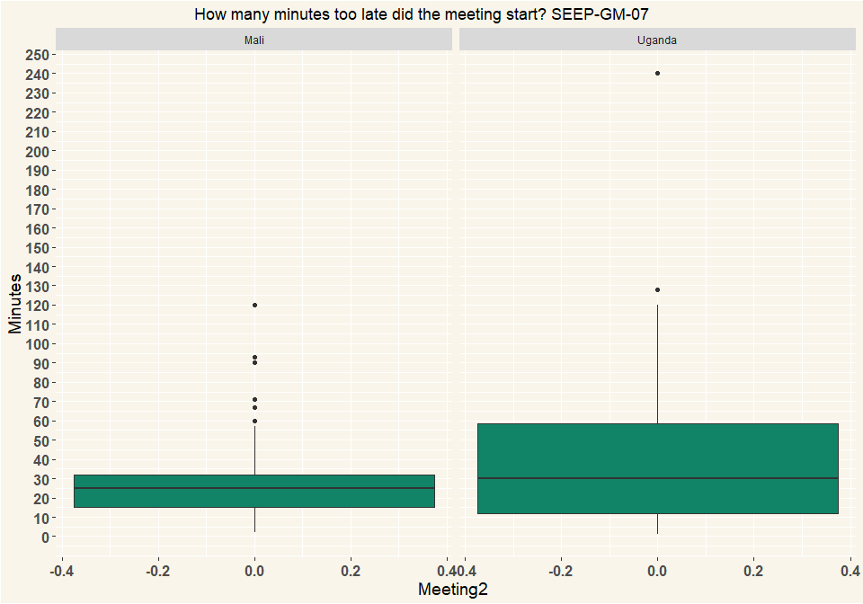

## [1] "G3"

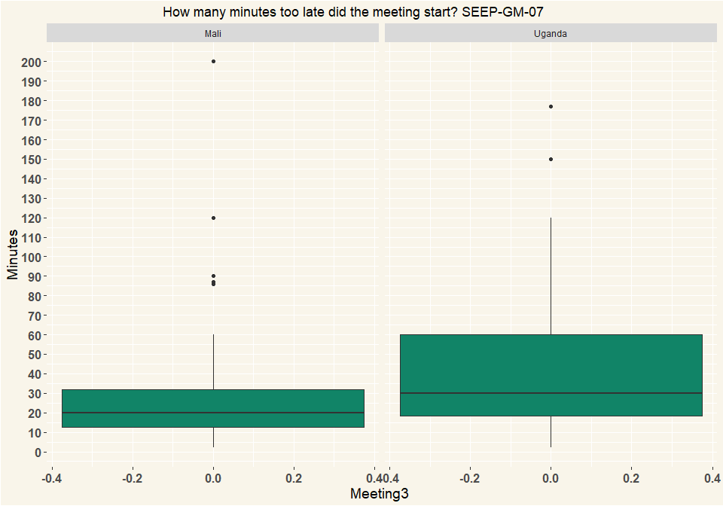

## group Mali Uganda  
## 1 Meeting1 86 81  
## 2 Meeting2 76 84  
## 3 Meeting3 59 79

# Q8 What was the reason/were the reasons the meeting started late? (Multiple Selection)

|  |  |  |  |  |  |  |
| --- | --- | --- | --- | --- | --- | --- |
| variable | Mali_G1 | Mali_G2 | Mali_G3 | Uganda_G1 | Uganda_G2 | Uganda_G3 |
| Chairperson or other committee members were late | 3 | 11 | 14 | 18 | 25 | 30 |
| Members were late | 70 | 62 | 53 | 60 | 61 | 57 |
| The location was not ready yet | 1 | 5 | 8 | 6 | 5 | 2 |
| People were first talking and discussing | 3 | 6 | 2 | 8 | 13 | 11 |
| Nobody paid attention to the time | 2 | 2 | 0 | 12 | 12 | 7 |
| Other (specify) | 12 | 5 | 3 | 12 | 10 | 11 |

|  |  |  |  |  |  |  |
| --- | --- | --- | --- | --- | --- | --- |
| variable | Mali_G1 | Mali_G2 | Mali_G3 | Uganda_G1 | Uganda_G2 | Uganda_G3 |
| Chairperson or other committee members were late | 0.033 | 0.1210 | 0.1750 | 0.1550 | 0.1980 | 0.2540 |
| Members were late | 0.769 | 0.6810 | 0.6620 | 0.5170 | 0.4840 | 0.4830 |
| The location was not ready yet | 0.011 | 0.0549 | 0.1000 | 0.0517 | 0.0397 | 0.0169 |
| People were first talking and discussing | 0.033 | 0.0659 | 0.0250 | 0.0690 | 0.1030 | 0.0932 |
| Nobody paid attention to the time | 0.022 | 0.0220 | 0.0000 | 0.1030 | 0.0952 | 0.0593 |
| Other (specify) | 0.132 | 0.0549 | 0.0375 | 0.1030 | 0.0794 | 0.0932 |

|  |  |
| --- | --- |
| Country | n |
| Mali | 152 |
| Uganda | 141 |

|  |  |
| --- | --- |
| Country | n |
| Mali | 152 |
| Uganda | 143 |

|  |  |
| --- | --- |
| Country | n |
| Mali | 152 |
| Uganda | 136 |

# Q9 Did the meeting start with a specific ritual, like a prayer, a song, a speech? (Multiple Selection)

|  |  |  |  |  |  |  |
| --- | --- | --- | --- | --- | --- | --- |
| variable | Mali_G1 | Mali_G2 | Mali_G3 | Uganda_G1 | Uganda_G2 | Uganda_G3 |
| A song or dance | 19 | 22 | 20 | 0 | 1 | 1 |
| A prayer | 25 | 30 | 28 | 94 | 106 | 99 |
| A speech | 38 | 50 | 45 | 55 | 43 | 38 |
| Reciting group rules/constitution | 74 | 99 | 120 | 2 | 1 | 1 |
| Other (specify) | 22 | 2 | 9 | 21 | 14 | 15 |

|  |  |  |  |  |  |  |
| --- | --- | --- | --- | --- | --- | --- |
| variable | Mali_G1 | Mali_G2 | Mali_G3 | Uganda_G1 | Uganda_G2 | Uganda_G3 |
| A song or dance | 0.107 | 0.108 | 0.0901 | 0 | 0.00606 | 0.00649 |
| A prayer | 0.14 | 0.148 | 0.126 | 0.547 | 0.642 | 0.643 |
| A speech | 0.213 | 0.246 | 0.203 | 0.32 | 0.261 | 0.247 |
| Reciting group rules/constitution | 0.416 | 0.488 | 0.541 | 0.0116 | 0.00606 | 0.00649 |
| Other (specify) | 0.124 | 0.00985 | 0.0405 | 0.122 | 0.0848 | 0.0974 |
| Percentage | 1 | 1 | 1 | 1 | 1 | 1 |

## # A tibble: 2 x 2  
## Country n  
## <chr> <int>  
## 1 Mali 152  
## 2 Uganda 141

## # A tibble: 2 x 2  
## Country n  
## <chr> <int>  
## 1 Mali 152  
## 2 Uganda 143

## # A tibble: 2 x 2  
## Country n  
## <chr> <int>  
## 1 Mali 152  
## 2 Uganda 136

# Q10 Did the meeting have a round of questions or comment where each member got a chance to speak?

|  |  |  |  |  |  |  |
| --- | --- | --- | --- | --- | --- | --- |
| Questions | Mali_G1 | Mali_G2 | Mali_G3 | Uganda_G1 | Uganda_G2 | Uganda_G3 |
| Yes | 144 | 132 | 127 | 79 | 64 | 47 |
| No | 8 | 20 | 25 | 62 | 77 | 89 |
| Other (specify) | 0 | 0 | 0 | 0 | 1 | 0 |
| I don’t know | 0 | 0 | 0 | 0 | 1 | 0 |
| Respondents | 152 | 152 | 152 | 141 | 143 | 136 |

|  |  |  |  |  |  |  |
| --- | --- | --- | --- | --- | --- | --- |
| Questions | Mali_G1 | Mali_G2 | Mali_G3 | Uganda_G1 | Uganda_G2 | Uganda_G3 |
| Yes | 0.947 | 0.868 | 0.836 | 0.56 | 0.448 | 0.346 |
| No | 0.0526 | 0.132 | 0.164 | 0.44 | 0.538 | 0.654 |
| Other (specify) | 0 | 0 | 0 | 0 | 0.00699 | 0 |
| I don’t know | 0 | 0 | 0 | 0 | 0.00699 | 0 |
| Percentage | 1 | 1 | 1 | 1 | 1 | 1 |

# Q11 How were the savings collected?

|  |  |  |  |  |  |  |
| --- | --- | --- | --- | --- | --- | --- |
| Savings | Mali_G1 | Mali_G2 | Mali_G3 | Uganda_G1 | Uganda_G2 | Uganda_G3 |
| One member was called at a time | 82 | 82 | 83 | 138 | 138 | 135 |
| All members put their savings at the same time | 35 | 47 | 47 | 0 | 4 | 1 |
| It was supposed to be one member at a time but it was chaotic and some doing at same time | 0 | 0 | 0 | 3 | 1 | 0 |
| Other (specify) | 35 | 23 | 22 | 0 | 0 | 0 |
| Respondents | 152 | 152 | 152 | 141 | 143 | 136 |

|  |  |  |  |  |  |  |
| --- | --- | --- | --- | --- | --- | --- |
| Savings | Mali_G1 | Mali_G2 | Mali_G3 | Uganda_G1 | Uganda_G2 | Uganda_G3 |
| One member was called at a time | 0.539 | 0.539 | 0.546 | 0.979 | 0.965 | 0.993 |
| All members put their savings at the same time | 0.23 | 0.309 | 0.309 | 0 | 0.028 | 0.00735 |
| It was supposed to be one member at a time but it was chaotic and some doing at same time | 0 | 0 | 0 | 0.0213 | 0.00699 | 0 |
| Other (specify) | 0.23 | 0.151 | 0.145 | 0 | 0 | 0 |
| Percentage | 1 | 1 | 1 | 1 | 1 | 1 |

# Others in Q_11

|  |  |  |
| --- | --- | --- |
| Country | Others | n |
| Mali | NA | 379 |
| Mali | appel | 1 |
| Mali | appel 1 en 1 | 1 |
| Mali | c’est le jour de partage | 1 |
| Mali | chacun a déposé son argent tour a tour | 1 |
| Mali | chacun de membre depose a tour de rôle | 1 |
| Mali | chacun depose a tour de rôle | 1 |
| Mali | chacun depose sa cotisation tour a tour | 1 |
| Mali | chacun depose son argent a tour de role | 2 |
| Mali | chacun depose son argent a tour de rôle | 39 |
| Mali | chacun depose son argent tour a tour | 1 |
| Mali | chacun depose son argent tour de rôle | 1 |
| Mali | chacun des membres depose son argent a tour de rôle | 1 |
| Mali | chacun le montrant d’epargne tour a tour | 1 |
| Mali | chaque membre depose son argent a tour de rôle | 2 |
| Mali | chaque membre depose son argent tour a tour | 2 |
| Mali | chaque membres depose sa cotisation a tour de rôle | 1 |
| Mali | chaque membres depose son argent a tour de rôle | 5 |
| Mali | chaque membres depose son argent a tour rôle | 1 |
| Mali | l’epargne a ete faite 1en 1 | 1 |
| Mali | la plus part on envoyer leur argent via un membre du groupe | 1 |
| Mali | la secretaire fait appel et chaque personne appelée depose son epargne | 1 |
| Mali | le secretaire procede a l’appel | 1 |
| Mali | les chacun depose son argent a tour de rôle | 1 |
| Mali | les membres depose l’argent a tour de rôle | 1 |
| Mali | les membres depose son argent a tour de rôle | 1 |
| Mali | les membres déposent leur argent sur appel de secrétaire administrative | 1 |
| Mali | les membres déposent leur épargne à tour de rôle sur appel de secrétaire administrative | 1 |
| Mali | les membres déposent leur épargne sur appel de secrétaire administrative. | 2 |
| Mali | les membres déposent leur épargne sur l’appel de secrétaire administrative. | 1 |
| Mali | les membres du groupe depose l’argent a tour de role suite a un appel | 1 |
| Mali | les membres ont ete appele 1en1 pour deposer l’argent et enregistre a travers xun croix qui signe que c,est payer | 1 |
| Mali | les ont été appelle chacune pour leurs dépôts | 1 |
| Mali | par appel | 1 |
| Mali | tours a tours | 1 |
| Uganda | NA | 465 |

# Q12 Did each savings amount get counted?

|  |  |  |  |  |  |  |
| --- | --- | --- | --- | --- | --- | --- |
| Savings | Mali_G1 | Mali_G2 | Mali_G3 | Uganda_G1 | Uganda_G2 | Uganda_G3 |
| Yes, each savings amount got counted and the total was announced by a money counter | 140 | 147 | 146 | 122 | 138 | 133 |
| Yes, each savings amount got counted but total not announced | 10 | 3 | 3 | 17 | 4 | 3 |
| No, savings was not counted but put in view of others without counting | 2 | 1 | 3 | 2 | 1 | 0 |
| No, savings was not counted and not in view of others | 0 | 1 | 0 | 0 | 0 | 0 |
| Respondents | 152 | 152 | 152 | 141 | 143 | 136 |

|  |  |  |  |  |  |  |
| --- | --- | --- | --- | --- | --- | --- |
| Savings | Mali_G1 | Mali_G2 | Mali_G3 | Uganda_G1 | Uganda_G2 | Uganda_G3 |
| Yes, each savings amount got counted and the total was announced by a money counter | 0.921 | 0.967 | 0.961 | 0.865 | 0.965 | 0.978 |
| Yes, each savings amount got counted but total not announced | 0.0658 | 0.0197 | 0.0197 | 0.121 | 0.028 | 0.0221 |
| No, savings was not counted but put in view of others without counting | 0.0132 | 0.00658 | 0.0197 | 0.0142 | 0.00699 | 0 |
| No, savings was not counted and not in view of others | 0 | 0.00658 | 0 | 0 | 0 | 0 |
| Percentage | 1 | 1 | 1 | 1 | 1 | 1 |

# Q14 How were the savings recorded?

|  |  |  |  |  |  |  |
| --- | --- | --- | --- | --- | --- | --- |
| Savings | Mali_G1 | Mali_G2 | Mali_G3 | Uganda_G1 | Uganda_G2 | Uganda_G3 |
| Written record of each member’s savings | 97 | 120 | 87 | 136 | 138 | 129 |
| Non-written system for each members’s savings. | 8 | 1 | 21 | 4 | 1 | 5 |
| Some written system but only for total | 21 | 17 | 19 | 1 | 4 | 1 |
| Memory based system but only for total | 10 | 6 | 13 | 0 | 0 | 1 |
| Other (specify) | 16 | 8 | 12 | 0 | 0 | 0 |
| Respondents | 152 | 152 | 152 | 141 | 143 | 136 |

|  |  |  |  |  |  |  |
| --- | --- | --- | --- | --- | --- | --- |
| Savings | Mali_G1 | Mali_G2 | Mali_G3 | Uganda_G1 | Uganda_G2 | Uganda_G3 |
| Written record of each member’s savings | 0.638 | 0.789 | 0.572 | 0.965 | 0.965 | 0.949 |
| Non-written system for each members’s savings. | 0.0526 | 0.00658 | 0.138 | 0.0284 | 0.00699 | 0.0368 |
| Some written system but only for total | 0.138 | 0.112 | 0.125 | 0.00709 | 0.028 | 0.00735 |
| Memory based system but only for total | 0.0658 | 0.0395 | 0.0855 | 0 | 0 | 0.00735 |
| Other (specify) | 0.105 | 0.0526 | 0.0789 | 0 | 0 | 0 |
| Percentage | 1 | 1 | 1 | 1 | 1 | 1 |

|  |  |  |
| --- | --- | --- |
| Country | Others | n |
| Mali | NA | 423 |
| Mali | dans le grand registre commun de l’épargne | 1 |
| Mali | dans le registre commun de l’épargne | 1 |
| Mali | dans le registre commun du groupe | 15 |
| Mali | dans le registre commun du groupe d’épargne | 1 |
| Mali | dans registre commun du groupe | 1 |
| Mali | l’épargne est enregistré dans un registre commun. | 1 |
| Mali | le groupe utilise le système ecrit de l’ epargne de chaque membre mais aussi le système non ecrit pour l epargne de chaque membre (base sur la memoire) | 1 |
| Mali | le nombre de pierre | 1 |
| Mali | le nombre de pierre gardé | 3 |
| Mali | le registre global | 1 |
| Mali | nombre de pierre gardé | 1 |
| Mali | non | 1 |
| Mali | registre commun du groupe | 3 |
| Mali | selon le comptage des pierres | 1 |
| Mali | selon le nombre de pierre gardé | 2 |
| Mali | selon le nombre de pierres gardé | 1 |
| Mali | selon le nombre de pierres gardées | 1 |
| Uganda | NA | 465 |

# Q15 Do members have an individual pass-book?

|  |  |  |  |  |  |  |
| --- | --- | --- | --- | --- | --- | --- |
| Passbook | Mali_G1 | Mali_G2 | Mali_G3 | Uganda_G1 | Uganda_G2 | Uganda_G3 |
| Yes, and they keep it themselves and bring it to the meeting | 23 | 22 | 43 | 24 | 17 | 12 |
| Yes, but it is kept in the group | 3 | 0 | 0 | 100 | 105 | 108 |
| No, no passbooks | 126 | 130 | 109 | 15 | 18 | 14 |
| Other (specify) | 0 | 0 | 0 | 2 | 3 | 2 |
| Respondents | 152 | 152 | 152 | 141 | 143 | 136 |

|  |  |  |  |  |  |  |
| --- | --- | --- | --- | --- | --- | --- |
| Passbook | Mali_G1 | Mali_G2 | Mali_G3 | Uganda_G1 | Uganda_G2 | Uganda_G3 |
| Yes, and they keep it themselves and bring it to the meeting | 0.151 | 0.145 | 0.283 | 0.17 | 0.119 | 0.0882 |
| Yes, but it is kept in the group | 0.0197 | 0 | 0 | 0.709 | 0.734 | 0.794 |
| No, no passbooks | 0.829 | 0.855 | 0.717 | 0.106 | 0.126 | 0.103 |
| Other (specify) | 0 | 0 | 0 | 0.0142 | 0.021 | 0.0147 |
| Percentage | 1 | 1 | 1 | 1 | 1 | 1 |

# Q16 Did the savings get recorded in the individual pass-books?

|  |  |  |  |  |  |  |
| --- | --- | --- | --- | --- | --- | --- |
| Passbook | Mali_G1 | Mali_G2 | Mali_G3 | Uganda_G1 | Uganda_G2 | Uganda_G3 |
| Yes, with stamps for each share bought | 1 | 0 | 1 | 117 | 116 | 112 |
| Yes, with a pen indicating each share bought | 21 | 22 | 17 | 6 | 7 | 8 |
| Yes, amounts written out | 1 | 0 | 5 | 1 | 1 | 2 |
| Other (specify) | 3 | 0 | 21 | 2 | 2 | 0 |
| Respondents | 26 | 22 | 44 | 126 | 126 | 122 |

|  |  |  |  |  |  |  |
| --- | --- | --- | --- | --- | --- | --- |
| Passbook | Mali_G1 | Mali_G2 | Mali_G3 | Uganda_G1 | Uganda_G2 | Uganda_G3 |
| Yes, with stamps for each share bought | 0.0385 | 0 | 0.0227 | 0.929 | 0.921 | 0.918 |
| Yes, with a pen indicating each share bought | 0.808 | 1 | 0.386 | 0.0476 | 0.0556 | 0.0656 |
| Yes, amounts written out | 0.0385 | 0 | 0.114 | 0.00794 | 0.00794 | 0.0164 |
| Other (specify) | 0.115 | 0 | 0.477 | 0.0159 | 0.0159 | 0 |
| Percentage | 1 | 1 | 1 | 1 | 1 | 1 |

# Q17 Did any of the group-members not save at all? How many did not save at all?

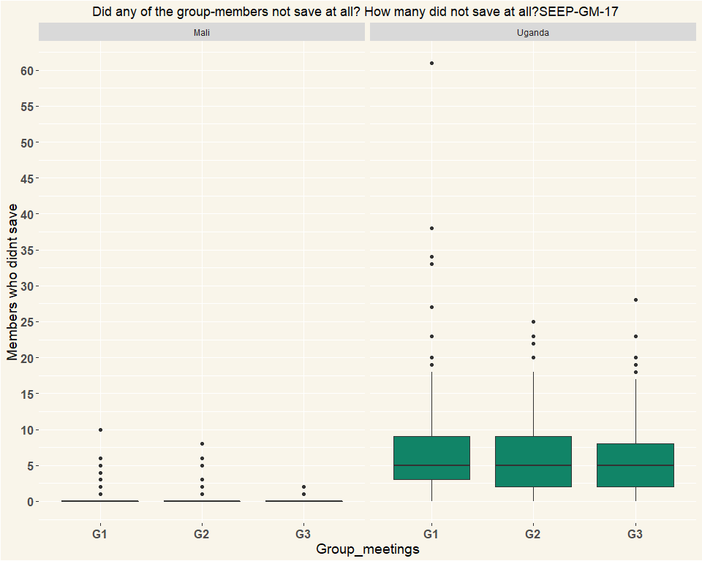

|  |  |  |  |
| --- | --- | --- | --- |
| Country | G1 | G2 | G3 |
| Mali | 152 | 152 | 152 |
| Uganda | 141 | 143 | 136 |

# Q18 Who did not save?

|  |  |  |  |  |  |  |
| --- | --- | --- | --- | --- | --- | --- |
| Non_savers | Mali_G1 | Mali_G2 | Mali_G3 | Uganda_G1 | Uganda_G2 | Uganda_G3 |
| People who were absent | 10 | 13 | 3 | 88 | 92 | 93 |
| People present | 3 | 0 | 1 | 0 | 0 | 1 |
| Both absent and present people | 4 | 3 | 1 | 31 | 30 | 22 |
| Respondents | 17 | 16 | 5 | 119 | 122 | 116 |

|  |  |  |  |  |  |  |
| --- | --- | --- | --- | --- | --- | --- |
| Non_savers | Mali_G1 | Mali_G2 | Mali_G3 | Uganda_G1 | Uganda_G2 | Uganda_G3 |
| People who were absent | 0.588 | 0.812 | 0.6 | 0.739 | 0.754 | 0.802 |
| People present | 0.176 | 0 | 0.2 | 0 | 0 | 0.00862 |
| Both absent and present people | 0.235 | 0.188 | 0.2 | 0.261 | 0.246 | 0.19 |
| Percentage | 1 | 1 | 1 | 1 | 1 | 1 |

# Q19 Was it considered against the rules that some people did not save?

|  |  |  |  |  |  |  |
| --- | --- | --- | --- | --- | --- | --- |
| Non_savers | Mali_G1 | Mali_G2 | Mali_G3 | Uganda_G1 | Uganda_G2 | Uganda_G3 |
| Yes, very much | 12 | 12 | 7 | 26 | 27 | 19 |
| Yes, but no big deal made of it | 3 | 0 | 0 | 41 | 37 | 34 |
| No, did not seem to | 2 | 4 | 0 | 43 | 56 | 61 |
| No, it was clearly according to the rules, it is allowed to miss savings | 0 | 0 | 0 | 8 | 1 | 1 |
| Other (specify) | 0 | 0 | 0 | 2 | 1 | 1 |
| Respondents | 17 | 16 | 7 | 120 | 122 | 116 |

|  |  |  |  |  |  |  |
| --- | --- | --- | --- | --- | --- | --- |
| Non_savers | Mali_G1 | Mali_G2 | Mali_G3 | Uganda_G1 | Uganda_G2 | Uganda_G3 |
| Yes, very much | 0.706 | 0.75 | 1 | 0.217 | 0.221 | 0.164 |
| Yes, but no big deal made of it | 0.176 | 0 | 0 | 0.342 | 0.303 | 0.293 |
| No, did not seem to | 0.118 | 0.25 | 0 | 0.358 | 0.459 | 0.526 |
| No, it was clearly according to the rules, it is allowed to miss savings | 0 | 0 | 0 | 0.0667 | 0.0082 | 0.00862 |
| Other (specify) | 0 | 0 | 0 | 0.0167 | 0.0082 | 0.00862 |
| Percentage | 1 | 1 | 1 | 1 | 1 | 1 |

# Q20 Did the group give out loans at the meeting?

|  |  |  |  |  |  |  |
| --- | --- | --- | --- | --- | --- | --- |
| Loans | Mali_G1 | Mali_G2 | Mali_G3 | Uganda_G1 | Uganda_G2 | Uganda_G3 |
| Yes | 62 | 70 | 67 | 97 | 77 | 70 |
| No | 90 | 82 | 85 | 42 | 66 | 66 |
| Other (specify) | 0 | 0 | 0 | 2 | 0 | 0 |
| Respondents | 152 | 152 | 152 | 141 | 143 | 136 |

|  |  |  |  |  |  |  |
| --- | --- | --- | --- | --- | --- | --- |
| Loans | Mali_G1 | Mali_G2 | Mali_G3 | Uganda_G1 | Uganda_G2 | Uganda_G3 |
| Yes | 0.408 | 0.461 | 0.441 | 0.688 | 0.538 | 0.515 |
| No | 0.592 | 0.539 | 0.559 | 0.298 | 0.462 | 0.485 |
| Other (specify) | 0 | 0 | 0 | 0.0142 | 0 | 0 |
| Percentage | 1 | 1 | 1 | 1 | 1 | 1 |

# Q22 Did people request loans or were they offered loans?

|  |  |  |  |  |  |  |
| --- | --- | --- | --- | --- | --- | --- |
| Loans | Mali_G1 | Mali_G2 | Mali_G3 | Uganda_G1 | Uganda_G2 | Uganda_G3 |
| Each member had the chance to request for a loan | 59 | 70 | 66 | 85 | 73 | 62 |
| Specific members were asked whether they wanted a loan | 2 | 0 | 2 | 3 | 3 | 6 |
| Specific members were assigned to get a loan | 1 | 0 | 0 | 6 | 1 | 2 |
| Other (specify) | 0 | 0 | 0 | 5 | 3 | 2 |
| Respondents | 62 | 70 | 68 | 99 | 80 | 72 |

|  |  |  |  |  |  |  |
| --- | --- | --- | --- | --- | --- | --- |
| Loans | Mali_G1 | Mali_G2 | Mali_G3 | Uganda_G1 | Uganda_G2 | Uganda_G3 |
| Each member had the chance to request for a loan | 0.952 | 1 | 0.971 | 0.859 | 0.912 | 0.861 |
| Specific members were asked whether they wanted a loan | 0.0323 | 0 | 0.0294 | 0.0303 | 0.0375 | 0.0833 |
| Specific members were assigned to get a loan | 0.0161 | 0 | 0 | 0.0606 | 0.0125 | 0.0278 |
| Other (specify) | 0 | 0 | 0 | 0.0505 | 0.0375 | 0.0278 |
| Percentage | 1 | 1 | 1 | 1 | 1 | 1 |

# Others File

## # A tibble: 10 x 3  
## # Groups: Country, Others [10]  
## Country Others n  
## <chr> <chr> <int>  
## 1 Uganda a member who was fisrt on the list was given a loan 1  
## 2 Uganda members are free to request for aloan as long as someone ~ 1  
## 3 Uganda members requested,,,also earlier request from during the ~ 1  
## 4 Uganda members were asked if they needed loans 1  
## 5 Uganda members were taking in turns 1  
## 6 Uganda only one member requested for a loan 1  
## 7 Uganda the first members on the list got loans 1  
## 8 Uganda the members who wanted loans had to request for it. 1  
## 9 Uganda there was a member who was already on the list 1  
## 10 Uganda there were more members who requested for loans but only ~ 1

# Q23 How were the loan allocated?

|  |  |  |  |  |  |  |
| --- | --- | --- | --- | --- | --- | --- |
| Loans | Mali_G1 | Mali_G2 | Mali_G3 | Uganda_G1 | Uganda_G2 | Uganda_G3 |
| There were more applicants for loans than available loans, so only some were successful at getting a loan | 34 | 31 | 27 | 44 | 37 | 39 |
| All those requesting a loan received a loan | 27 | 39 | 40 | 49 | 41 | 32 |
| Loans were given (it was assumed all wanted a loan) | 0 | 0 | 1 | 0 | 0 | 0 |
| Other (specify) | 1 | 0 | 0 | 6 | 2 | 1 |
| Respondents | 62 | 70 | 68 | 99 | 80 | 72 |

|  |  |  |  |  |  |  |
| --- | --- | --- | --- | --- | --- | --- |
| Loans | Mali_G1 | Mali_G2 | Mali_G3 | Uganda_G1 | Uganda_G2 | Uganda_G3 |
| There were more applicants for loans than available loans, so only some were successful at getting a loan | 0.548 | 0.443 | 0.397 | 0.444 | 0.462 | 0.542 |
| All those requesting a loan received a loan | 0.435 | 0.557 | 0.588 | 0.495 | 0.512 | 0.444 |
| Loans were given (it was assumed all wanted a loan) | 0 | 0 | 0.0147 | 0 | 0 | 0 |
| Other (specify) | 0.0161 | 0 | 0 | 0.0606 | 0.025 | 0.0139 |
| Percentage | 1 | 1 | 1 | 1 | 1 | 1 |

# Q24 Did loan recipients need to meet financial criteria?

|  |  |  |  |  |  |  |
| --- | --- | --- | --- | --- | --- | --- |
| Loans | Mali_G1 | Mali_G2 | Mali_G3 | Uganda_G1 | Uganda_G2 | Uganda_G3 |
| Yes, record keeper verified that loans were within a specified multiple of member’s savings. | 27 | 21 | 17 | 67 | 55 | 40 |
| Yes, loan eligibility depended on previous repayment or other criteria | 11 | 9 | 15 | 23 | 11 | 14 |
| No, anyone could take a loan | 24 | 39 | 36 | 8 | 12 | 18 |
| Other(specify) | 0 | 1 | 0 | 1 | 2 | 0 |
| Respondents | 62 | 70 | 68 | 99 | 80 | 72 |

|  |  |  |  |  |  |  |
| --- | --- | --- | --- | --- | --- | --- |
| Loans | Mali_G1 | Mali_G2 | Mali_G3 | Uganda_G1 | Uganda_G2 | Uganda_G3 |
| Yes, record keeper verified that loans were within a specified multiple of member’s savings. | 0.435 | 0.3 | 0.25 | 0.677 | 0.688 | 0.556 |
| Yes, loan eligibility depended on previous repayment or other criteria | 0.177 | 0.129 | 0.221 | 0.232 | 0.138 | 0.194 |
| No, anyone could take a loan | 0.387 | 0.557 | 0.529 | 0.0808 | 0.15 | 0.25 |
| Other(specify) | 0 | 0.0143 | 0 | 0.0101 | 0.025 | 0 |
| Percentage | 1 | 1 | 1 | 1 | 1 | 1 |

# Q25 Were any rules about loan purpose applied or discussed?

|  |  |  |  |  |  |  |
| --- | --- | --- | --- | --- | --- | --- |
| Loans | Mali_G1 | Mali_G2 | Mali_G3 | Uganda_G1 | Uganda_G2 | Uganda_G3 |
| Yes, loan purpose had to be productive | 15 | 4 | 22 | 40 | 33 | 18 |
| Yes, loan purpose had to be useful (could be productive, emergencies, school fees…) | 22 | 27 | 24 | 10 | 4 | 2 |
| loan purpose was mentioned but no criteria seemed required | 5 | 10 | 1 | 11 | 9 | 7 |
| Loan purpose was not discussed | 20 | 29 | 21 | 35 | 33 | 42 |
| Other (specify) | 0 | 0 | 0 | 3 | 1 | 3 |
| Respondents | 62 | 70 | 68 | 99 | 80 | 72 |

|  |  |  |  |  |  |  |
| --- | --- | --- | --- | --- | --- | --- |
| Loans | Mali_G1 | Mali_G2 | Mali_G3 | Uganda_G1 | Uganda_G2 | Uganda_G3 |
| Yes, loan purpose had to be productive | 0.242 | 0.0571 | 0.324 | 0.404 | 0.412 | 0.25 |
| Yes, loan purpose had to be useful (could be productive, emergencies, school fees…) | 0.355 | 0.386 | 0.353 | 0.101 | 0.05 | 0.0278 |
| loan purpose was mentioned but no criteria seemed required | 0.0806 | 0.143 | 0.0147 | 0.111 | 0.112 | 0.0972 |
| Loan purpose was not discussed | 0.323 | 0.414 | 0.309 | 0.354 | 0.412 | 0.583 |
| Other (specify) | 0 | 0 | 0 | 0.0303 | 0.0125 | 0.0417 |
| Percentage | 1 | 1 | 1 | 1 | 1 | 1 |

# Q26 Who made the loan approval decision?

|  |  |  |  |  |  |  |
| --- | --- | --- | --- | --- | --- | --- |
| Loans | Mali_G1 | Mali_G2 | Mali_G3 | Uganda_G1 | Uganda_G2 | Uganda_G3 |
| The chairperson | 8 | 3 | 6 | 8 | 11 | 5 |
| The committee | 26 | 23 | 22 | 24 | 21 | 28 |
| The entire savings-group (voting) | 7 | 5 | 14 | 31 | 27 | 30 |
| Just by discussion, nobody decided | 6 | 15 | 8 | 24 | 14 | 7 |
| All requests automatically approved | 14 | 24 | 18 | 10 | 7 | 2 |
| Other (specify) | 1 | 0 | 0 | 2 | 0 | 0 |
| Respondents | 62 | 70 | 68 | 99 | 80 | 72 |

|  |  |  |  |  |  |  |
| --- | --- | --- | --- | --- | --- | --- |
| Loans | Mali_G1 | Mali_G2 | Mali_G3 | Uganda_G1 | Uganda_G2 | Uganda_G3 |
| The chairperson | 0.129 | 0.0429 | 0.0882 | 0.0808 | 0.138 | 0.0694 |
| The committee | 0.419 | 0.329 | 0.324 | 0.242 | 0.262 | 0.389 |
| The entire savings-group (voting) | 0.113 | 0.0714 | 0.206 | 0.313 | 0.338 | 0.417 |
| Just by discussion, nobody decided | 0.0968 | 0.214 | 0.118 | 0.242 | 0.175 | 0.0972 |
| All requests automatically approved | 0.226 | 0.343 | 0.265 | 0.101 | 0.0875 | 0.0278 |
| Other (specify) | 0.0161 | 0 | 0 | 0.0202 | 0 | 0 |
| Percentage | 1 | 1 | 1 | 1 | 1 | 1 |

# Q27 What is the interest rate charged for loans given at the meeting?

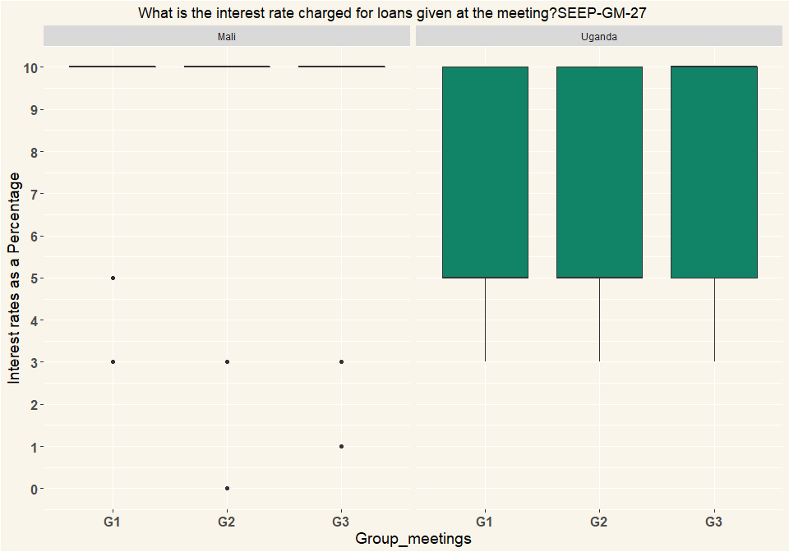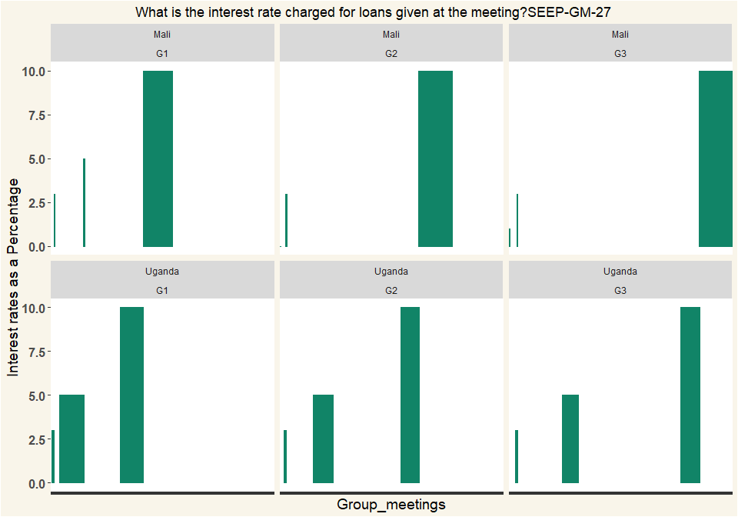

|  |  |  |  |
| --- | --- | --- | --- |
| Country | G1 | G2 | G3 |
| Mali | 62 | 70 | 68 |
| Uganda | 99 | 80 | 72 |

# Q28 how is that calculated?

|  |  |  |  |  |  |  |
| --- | --- | --- | --- | --- | --- | --- |
| Calculated | Mali_G1 | Mali_G2 | Mali_G3 | Uganda_G1 | Uganda_G2 | Uganda_G3 |
| One time, on amount borrowed. | 4 | 10 | 5 | 14 | 7 | 1 |
| Monthly, for period borrowed. | 55 | 58 | 62 | 57 | 46 | 42 |
| Recalculated each month on declining balance of loan | 0 | 2 | 1 | 28 | 26 | 28 |
| Other: | 3 | 0 | 0 | 0 | 1 | 1 |
| Respondents | 62 | 70 | 68 | 99 | 80 | 72 |

|  |  |  |  |  |  |  |
| --- | --- | --- | --- | --- | --- | --- |
| Calculated | Mali_G1 | Mali_G2 | Mali_G3 | Uganda_G1 | Uganda_G2 | Uganda_G3 |
| One time, on amount borrowed. | 0.0645 | 0.143 | 0.0735 | 0.141 | 0.0875 | 0.0139 |
| Monthly, for period borrowed. | 0.887 | 0.829 | 0.912 | 0.576 | 0.575 | 0.583 |
| Recalculated each month on declining balance of loan | 0 | 0.0286 | 0.0147 | 0.283 | 0.325 | 0.389 |
| Other: | 0.0484 | 0 | 0 | 0 | 0.0125 | 0.0139 |
| Percentage | 1 | 1 | 1 | 1 | 1 | 1 |

# Q29 Did the group make any other decisions?

|  |  |  |  |  |  |  |
| --- | --- | --- | --- | --- | --- | --- |
| Calculated | Mali_G1 | Mali_G2 | Mali_G3 | Uganda_G1 | Uganda_G2 | Uganda_G3 |
| One time, on amount borrowed. | 0.0645 | 0.143 | 0.0735 | 0.141 | 0.0875 | 0.0139 |
| Monthly, for period borrowed. | 0.887 | 0.829 | 0.912 | 0.576 | 0.575 | 0.583 |
| Recalculated each month on declining balance of loan | 0 | 0.0286 | 0.0147 | 0.283 | 0.325 | 0.389 |
| Other: | 0.0484 | 0 | 0 | 0 | 0.0125 | 0.0139 |
| Percentage | 1 | 1 | 1 | 1 | 1 | 1 |

|  |  |  |  |  |  |  |
| --- | --- | --- | --- | --- | --- | --- |
| variable | Mali_G1 | Mali_G2 | Mali_G3 | Uganda_G1 | Uganda_G2 | Uganda_G3 |
| New rules | 23 | 21 | 4 | 4 | 2 | 2 |
| Change rule(s) | 3 | 6 | 0 | 3 | 2 | 0 |
| Allowing new members | 2 | 106 | 108 | 3 | 136 | 130 |
| NA | 28 | 133 | 112 | 10 | 140 | 132 |

|  |  |  |  |  |  |  |
| --- | --- | --- | --- | --- | --- | --- |
| variable | Mali_G1 | Mali_G2 | Mali_G3 | Uganda_G1 | Uganda_G2 | Uganda_G3 |
| New rules | 0.821 | 0.158 | 0.0357 | 0.4 | 0.0143 | 0.0152 |
| Change rule(s) | 0.107 | 0.0451 | 0 | 0.3 | 0.0143 | 0 |
| Allowing new members | 0.0714 | 0.797 | 0.964 | 0.3 | 0.971 | 0.985 |
| NA | 1 | 1 | 1 | 1 | 1 | 1 |

# 30 Who made the decision about {0} ?

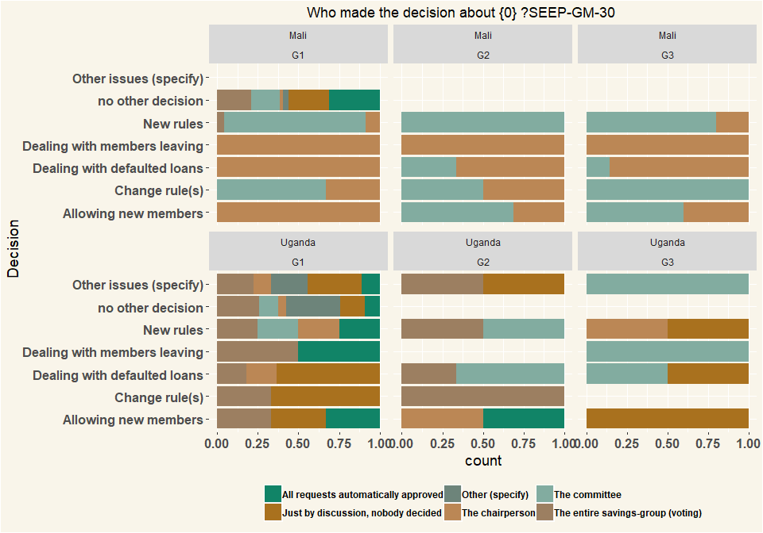

# Others Files

## # A tibble: 18 x 3  
## # Groups: Country, test [18]  
## Country test n  
## <chr> <chr> <int>  
## 1 Mali il n'ya pas eu d'octroi a ce jour 1  
## 2 Mali pas de décisions 1  
## 3 Uganda it was not on the agend 1  
## 4 Uganda No body 1  
## 5 Uganda no decision made 1  
## 6 Uganda No decision was made 1  
## 7 Uganda no decision were made. 1  
## 8 Uganda no one 1  
## 9 Uganda no one made the decisions. 1  
## 10 Uganda no other descision 1  
## 11 Uganda No rules 1  
## 12 Uganda none 4  
## 13 Uganda None 5  
## 14 Uganda None made a decision 1  
## 15 Uganda nothing 1  
## 16 Uganda Nothing at all 1  
## 17 Uganda Nothing was done 1  
## 18 Uganda there was no rule 1

# Q31 Did the group have any conflict or disagreement in the meeting?

|  |  |  |  |  |  |  |
| --- | --- | --- | --- | --- | --- | --- |
| Conflict | Mali_G1 | Mali_G2 | Mali_G3 | Uganda_G1 | Uganda_G2 | Uganda_G3 |
| Yes, a large disagreement/conflict | 3 | 0 | 1 | 3 | 0 | 0 |
| Yes, just small disagreements | 4 | 5 | 0 | 18 | 7 | 3 |
| No, I did not notice anything | 124 | 133 | 151 | 119 | 135 | 132 |
| Other (specify) | 21 | 14 | 0 | 1 | 1 | 1 |
| Respondents | 152 | 152 | 152 | 141 | 143 | 136 |

|  |  |  |  |  |  |  |
| --- | --- | --- | --- | --- | --- | --- |
| Conflict | Mali_G1 | Mali_G2 | Mali_G3 | Uganda_G1 | Uganda_G2 | Uganda_G3 |
| Yes, a large disagreement/conflict | 0.0197 | 0 | 0.00658 | 0.0213 | 0 | 0 |
| Yes, just small disagreements | 0.0263 | 0.0329 | 0 | 0.128 | 0.049 | 0.0221 |
| No, I did not notice anything | 0.816 | 0.875 | 0.993 | 0.844 | 0.944 | 0.971 |
| Other (specify) | 0.138 | 0.0921 | 0 | 0.00709 | 0.00699 | 0.00735 |
| Percentage | 1 | 1 | 1 | 1 | 1 | 1 |

## # A tibble: 8 x 3  
## # Groups: Country, Others [8]  
## Country Others n  
## <chr> <chr> <int>  
## 1 Mali pas 1  
## 2 Mali pas conflits 1  
## 3 Mali pas de conflits 29  
## 4 Mali Pas de conflits 3  
## 5 Mali pas des conflits 1  
## 6 Uganda one member had saved the previous week but this wasn't ind~ 1  
## 7 Uganda people are nolonger attending meeting only sent money to o~ 1  
## 8 Uganda some members are not saving 1

# Q32 Was the conflict or disagreement resolved?

|  |  |  |  |  |  |  |
| --- | --- | --- | --- | --- | --- | --- |
| Conflict | Mali_G1 | Mali_G2 | Mali_G3 | Uganda_G1 | Uganda_G2 | Uganda_G3 |
| Yes | 8 | 3 | 0 | 17 | 6 | 1 |
| More or less | 0 | 2 | 3 | 2 | 1 | 2 |
| No | 0 | 0 | 0 | 2 | 0 | 0 |
| Respondents | 8 | 5 | 3 | 21 | 7 | 3 |

|  |  |  |  |  |  |  |
| --- | --- | --- | --- | --- | --- | --- |
| Conflict | Mali_G1 | Mali_G2 | Mali_G3 | Uganda_G1 | Uganda_G2 | Uganda_G3 |
| Yes | 1 | 0.6 | 0 | 0.81 | 0.857 | 0.333 |
| More or less | 0 | 0.4 | 1 | 0.0952 | 0.143 | 0.667 |
| No | 0 | 0 | 0 | 0.0952 | 0 | 0 |
| Percentage | 1 | 1 | 1 | 1 | 1 | 1 |

# 33 What was the issue?

## # A tibble: 47 x 2  
## # Groups: Others [47]  
## Others n  
## <chr> <int>  
## 1 -1 829  
## 2 1 membre ne viens pas régulièrement 1  
## 3 a member hadn't saved for four times and wanted to compasete with~ 1  
## 4 A member took loan and hes not saving for two month 1  
## 5 A member who didnt attend meeting on 25th April 2019 was complain~ 1  
## 6 about money,one member wanted loan above its savings and other me~ 1  
## 7 about the time and day of meeting some wanted monday and some wan~ 1  
## 8 Amember was given aloan without the concent of all members 1  
## 9 attendance and late coming 1  
## 10 beaucoup d'emprunts non remboursé 1  
## # ... with 37 more rows

# 34 How was it resolved?

## # A tibble: 44 x 2  
## # Groups: Others [44]  
## Others n  
## <chr> <int>  
## 1 -1 830  
## 2 b 1  
## 3 by counting money again 1  
## 4 by paying the fee 1  
## 5 by voting and those who wanted wednesday wins 1  
## 6 check her stamps and count for her. they like a while she agrees ~ 1  
## 7 elle sera remboursée de 1250 f par le groupe 1  
## 8 elle va venir régulièrement 1  
## 9 He was given social fund instead 1  
## 10 intervention 1  
## # ... with 34 more rows

# Q35 At the end of the meeting, how many members had outstanding loans?

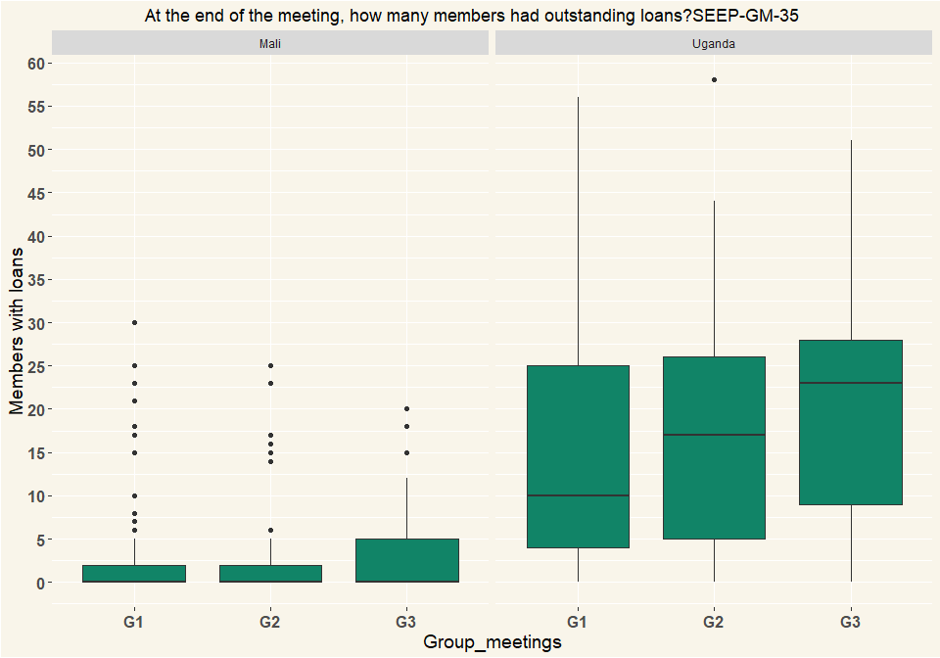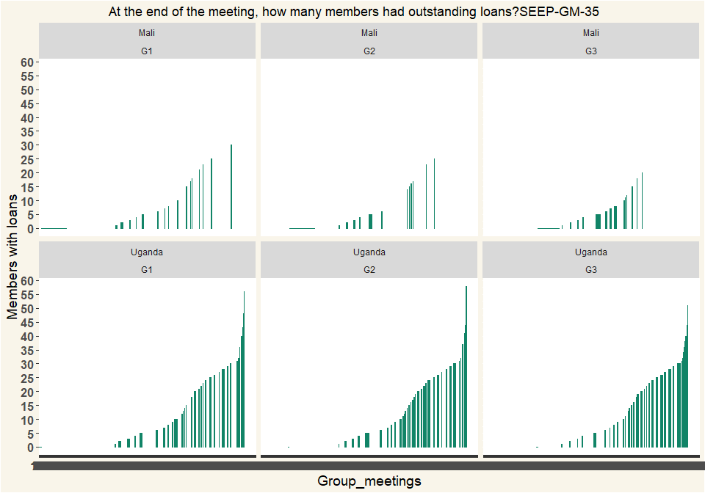

|  |  |  |  |
| --- | --- | --- | --- |
| Country | G1 | G2 | G3 |
| Mali | 152 | 152 | 152 |
| Uganda | 141 | 143 | 136 |

# Q36 Does the group have a social fund?

|  |  |  |  |  |  |  |
| --- | --- | --- | --- | --- | --- | --- |
| Fund | Mali_G1 | Mali_G2 | Mali_G3 | Uganda_G1 | Uganda_G2 | Uganda_G3 |
| Yes | 8 | 2 | 0 | 112 | 116 | 116 |
| No | 144 | 150 | 152 | 29 | 27 | 20 |
| Respondents | 152 | 152 | 152 | 141 | 143 | 136 |

|  |  |  |  |  |  |  |
| --- | --- | --- | --- | --- | --- | --- |
| Fund | Mali_G1 | Mali_G2 | Mali_G3 | Uganda_G1 | Uganda_G2 | Uganda_G3 |
| Yes | 0.0526 | 0.0132 | 0 | 0.794 | 0.811 | 0.853 |
| No | 0.947 | 0.987 | 1 | 0.206 | 0.189 | 0.147 |
| Percentage | 1 | 1 | 1 | 1 | 1 | 1 |

# Q37 How is it funded?

|  |  |  |  |  |  |  |
| --- | --- | --- | --- | --- | --- | --- |
| Fund | Mali_G1 | Mali_G2 | Mali_G3 | Uganda_G1 | Uganda_G2 | Uganda_G3 |
| Members contribute a fixed amount every meeting | 3 | 2 | 2 | 92 | 98 | 92 |
| Members contribute up to a certain amount then contributions are frozen until it drops below that amount. | 0 | 0 | 0 | 10 | 6 | 12 |
| Other: | 5 | 0 | 0 | 10 | 13 | 12 |
| Respondents | 8 | 2 | 2 | 112 | 117 | 116 |

|  |  |  |  |  |  |  |
| --- | --- | --- | --- | --- | --- | --- |
| Fund | Mali_G1 | Mali_G2 | Mali_G3 | Uganda_G1 | Uganda_G2 | Uganda_G3 |
| Members contribute a fixed amount every meeting | 0.375 | 1 | 1 | 0.821 | 0.838 | 0.793 |
| Members contribute up to a certain amount then contributions are frozen until it drops below that amount. | 0 | 0 | 0 | 0.0893 | 0.0513 | 0.103 |
| Other: | 0.625 | 0 | 0 | 0.0893 | 0.111 | 0.103 |
| Percentage | 1 | 1 | 1 | 1 | 1 | 1 |

# Q38 What are the conditions to access the social fund?

|  |  |  |  |  |  |  |
| --- | --- | --- | --- | --- | --- | --- |
| Fund | Mali_G1 | Mali_G2 | Mali_G3 | Uganda_G1 | Uganda_G2 | Uganda_G3 |
| Members borrow with interest | 2 | 0 | 1 | 2 | 3 | 2 |
| Members borrow without interest | 1 | 0 | 1 | 104 | 106 | 111 |
| Members are given gifts that are not repaid | 5 | 1 | 0 | 3 | 2 | 2 |
| Other: | 0 | 1 | 0 | 3 | 6 | 1 |
| Respondents | 8 | 2 | 2 | 112 | 117 | 116 |

|  |  |  |  |  |  |  |
| --- | --- | --- | --- | --- | --- | --- |
| Fund | Mali_G1 | Mali_G2 | Mali_G3 | Uganda_G1 | Uganda_G2 | Uganda_G3 |
| Members borrow with interest | 0.25 | 0 | 0.5 | 0.0179 | 0.0256 | 0.0172 |
| Members borrow without interest | 0.125 | 0 | 0.5 | 0.929 | 0.906 | 0.957 |
| Members are given gifts that are not repaid | 0.625 | 0.5 | 0 | 0.0268 | 0.0171 | 0.0172 |
| Other: | 0 | 0.5 | 0 | 0.0268 | 0.0513 | 0.00862 |
| Percentage | 1 | 1 | 1 | 1 | 1 | 1 |

# Q39 What are the criteria for receiving social fund money?

|  |  |  |  |  |  |  |
| --- | --- | --- | --- | --- | --- | --- |
| Fund | Mali_G1 | Mali_G2 | Mali_G3 | Uganda_G1 | Uganda_G2 | Uganda_G3 |
| Specific list of uses only (such as death, birth, injury) | 5 | 1 | 2 | 32 | 28 | 35 |
| Request money for any social need | 3 | 0 | 0 | 75 | 88 | 80 |
| Other (specify) | 0 | 1 | 0 | 5 | 1 | 1 |
| Respondents | 8 | 2 | 2 | 112 | 117 | 116 |

|  |  |  |  |  |  |  |
| --- | --- | --- | --- | --- | --- | --- |
| Fund | Mali_G1 | Mali_G2 | Mali_G3 | Uganda_G1 | Uganda_G2 | Uganda_G3 |
| Specific list of uses only (such as death, birth, injury) | 0.625 | 0.5 | 1 | 0.286 | 0.239 | 0.302 |
| Request money for any social need | 0.375 | 0 | 0 | 0.67 | 0.752 | 0.69 |
| Other (specify) | 0 | 0.5 | 0 | 0.0446 | 0.00855 | 0.00862 |
| Percentage | 1 | 1 | 1 | 1 | 1 | 1 |

# Q40 What is the balance of the Social Fund?

* Mali exchange rate 0.00169950
* Uganda exchange rate 0.000270226

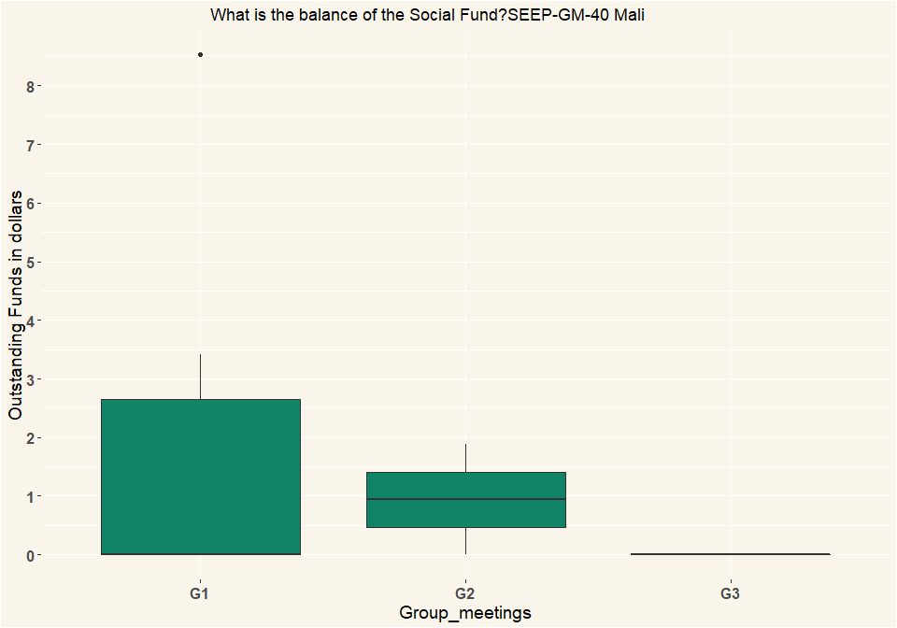

## [1] "Uganda"

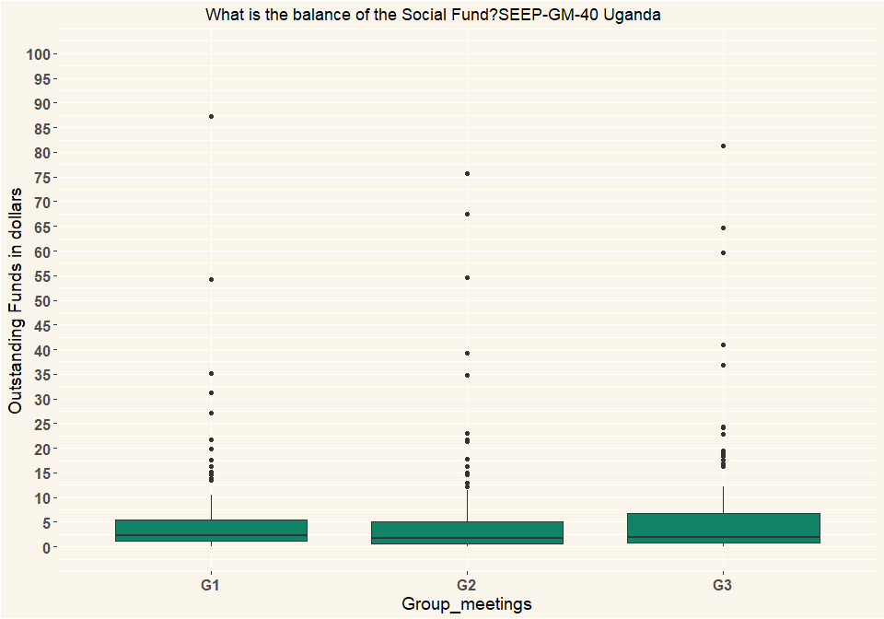

|  |  |  |  |
| --- | --- | --- | --- |
| Country | G1 | G2 | G3 |
| Mali | 8 | 2 | 2 |
| Uganda | 112 | 117 | 116 |

# Q41 Did any elections take place or get discussed for committee positions?

|  |  |  |  |  |  |  |
| --- | --- | --- | --- | --- | --- | --- |
| Elections | Mali_G1 | Mali_G2 | Mali_G3 | Uganda_G1 | Uganda_G2 | Uganda_G3 |
| No, not mentioned | 148 | 151 | 152 | 139 | 142 | 136 |
| Yes, discussed but planned for later | 2 | 0 | 0 | 1 | 0 | 0 |
| Yes, elections took place | 2 | 1 | 0 | 1 | 1 | 0 |
| Respondents | 152 | 152 | 152 | 141 | 143 | 136 |

|  |  |  |  |  |  |  |
| --- | --- | --- | --- | --- | --- | --- |
| Elections | Mali_G1 | Mali_G2 | Mali_G3 | Uganda_G1 | Uganda_G2 | Uganda_G3 |
| No, not mentioned | 0.974 | 0.993 | 1 | 0.986 | 0.993 | 1 |
| Yes, discussed but planned for later | 0.0132 | 0 | 0 | 0.00709 | 0 | 0 |
| Yes, elections took place | 0.0132 | 0.00658 | 0 | 0.00709 | 0.00699 | 0 |
| Percentage | 1 | 1 | 1 | 1 | 1 | 1 |

# Q44 How was the cash handled?

|  |  |  |  |  |  |  |
| --- | --- | --- | --- | --- | --- | --- |
| Cash | Mali_G1 | Mali_G2 | Mali_G3 | Uganda_G1 | Uganda_G2 | Uganda_G3 |
| Separate money counter/ separate bookkeeper/ separate treasurer, | 60 | 74 | 97 | 112 | 137 | 122 |
| Separate bookkeeper / treasurer | 83 | 75 | 55 | 24 | 4 | 10 |
| All done by same person | 9 | 3 | 0 | 5 | 2 | 4 |
| Respondents | 152 | 152 | 152 | 141 | 143 | 136 |

|  |  |  |  |  |  |  |
| --- | --- | --- | --- | --- | --- | --- |
| Cash | Mali_G1 | Mali_G2 | Mali_G3 | Uganda_G1 | Uganda_G2 | Uganda_G3 |
| Separate money counter/ separate bookkeeper/ separate treasurer, | 0.395 | 0.487 | 0.638 | 0.794 | 0.958 | 0.897 |
| Separate bookkeeper / treasurer | 0.546 | 0.493 | 0.362 | 0.17 | 0.028 | 0.0735 |
| All done by same person | 0.0592 | 0.0197 | 0 | 0.0355 | 0.014 | 0.0294 |
| Percentage | 1 | 1 | 1 | 1 | 1 | 1 |

# Q45 Where was the cash money stored between previous and this meeting?

|  |  |  |  |  |  |  |
| --- | --- | --- | --- | --- | --- | --- |
| Cash | Mali_G1 | Mali_G2 | Mali_G3 | Uganda_G1 | Uganda_G2 | Uganda_G3 |
| In a box with several locks | 5 | 1 | 1 | 125 | 116 | 102 |
| In a box with 1 lock | 144 | 149 | 150 | 2 | 0 | 1 |
| In another container that could be locked | 0 | 1 | 1 | 0 | 0 | 0 |
| In another container locked with one lock | 0 | 0 | 0 | 4 | 13 | 15 |
| No money was left (all lent out) | 1 | 1 | 0 | 0 | 0 | 0 |
| Other (specify) | 0 | 0 | 0 | 6 | 10 | 15 |
| Respondents | 150 | 152 | 152 | 137 | 139 | 133 |

|  |  |  |  |  |  |  |
| --- | --- | --- | --- | --- | --- | --- |
| Cash | Mali_G1 | Mali_G2 | Mali_G3 | Uganda_G1 | Uganda_G2 | Uganda_G3 |
| In a box with several locks | 0.0333 | 0.00658 | 0.00658 | 0.912 | 0.835 | 0.767 |
| In a box with 1 lock | 0.96 | 0.98 | 0.987 | 0.0146 | 0 | 0.00752 |
| In another container that could be locked | 0 | 0.00658 | 0.00658 | 0 | 0 | 0 |
| In another container locked with one lock | 0 | 0 | 0 | 0.0292 | 0.0935 | 0.113 |
| No money was left (all lent out) | 0.00667 | 0.00658 | 0 | 0 | 0 | 0 |
| Other (specify) | 0 | 0 | 0 | 0.0438 | 0.0719 | 0.113 |
| Percentage | 1 | 1 | 1 | 1 | 1 | 1 |

# Q46 Did any of the money from the group get stored in a (bank-)account or mobile money account between last and this meeting?

|  |  |  |  |  |  |  |
| --- | --- | --- | --- | --- | --- | --- |
| Cash | Mali_G1 | Mali_G2 | Mali_G3 | Uganda_G1 | Uganda_G2 | Uganda_G3 |
| Yes, all excess cash was stored in the account | 21 | 24 | 23 | 7 | 11 | 11 |
| Yes, some excess cash was stored in the account | 1 | 0 | 1 | 3 | 4 | 0 |
| No, the excess cash was too little | 30 | 26 | 23 | 23 | 23 | 16 |
| No, it was not considered | 94 | 102 | 105 | 90 | 99 | 102 |
| Other (specify) | 5 | 0 | 0 | 15 | 3 | 3 |
| I don’t know | 1 | 0 | 0 | 3 | 3 | 4 |
| Respondents | 152 | 152 | 152 | 141 | 143 | 136 |

|  |  |  |  |  |  |  |
| --- | --- | --- | --- | --- | --- | --- |
| Cash | Mali_G1 | Mali_G2 | Mali_G3 | Uganda_G1 | Uganda_G2 | Uganda_G3 |
| Yes, all excess cash was stored in the account | 0.138 | 0.158 | 0.151 | 0.0496 | 0.0769 | 0.0809 |
| Yes, some excess cash was stored in the account | 0.00658 | 0 | 0.00658 | 0.0213 | 0.028 | 0 |
| No, the excess cash was too little | 0.197 | 0.171 | 0.151 | 0.163 | 0.161 | 0.118 |
| No, it was not considered | 0.618 | 0.671 | 0.691 | 0.638 | 0.692 | 0.75 |
| Other (specify) | 0.0329 | 0 | 0 | 0.106 | 0.021 | 0.0221 |
| I don’t know | 0.00658 | 0 | 0 | 0.0213 | 0.021 | 0.0294 |
| Percentage | 1 | 1 | 1 | 1 | 1 | 1 |

# Q47 Did any of the money from the group get stored in different places, e.g. different group members?

|  |  |  |  |  |  |  |
| --- | --- | --- | --- | --- | --- | --- |
| Cash | Mali_G1 | Mali_G2 | Mali_G3 | Uganda_G1 | Uganda_G2 | Uganda_G3 |
| All in one place | 125 | 130 | 130 | 126 | 132 | 122 |
| In two places | 26 | 22 | 22 | 8 | 8 | 8 |
| Other (specify) | 1 | 0 | 0 | 4 | 3 | 2 |
| I don’t know | 0 | 0 | 0 | 3 | 0 | 4 |
| Respondents | 152 | 152 | 152 | 141 | 143 | 136 |

|  |  |  |  |  |  |  |
| --- | --- | --- | --- | --- | --- | --- |
| Cash | Mali_G1 | Mali_G2 | Mali_G3 | Uganda_G1 | Uganda_G2 | Uganda_G3 |
| All in one place | 0.822 | 0.855 | 0.855 | 0.894 | 0.923 | 0.897 |
| In two places | 0.171 | 0.145 | 0.145 | 0.0567 | 0.0559 | 0.0588 |
| Other (specify) | 0.00658 | 0 | 0 | 0.0284 | 0.021 | 0.0147 |
| I don’t know | 0 | 0 | 0 | 0.0213 | 0 | 0.0294 |
| Percentage | 1 | 1 | 1 | 1 | 1 | 1 |

# Q48 How many members attended in total? (Multiple Selection)

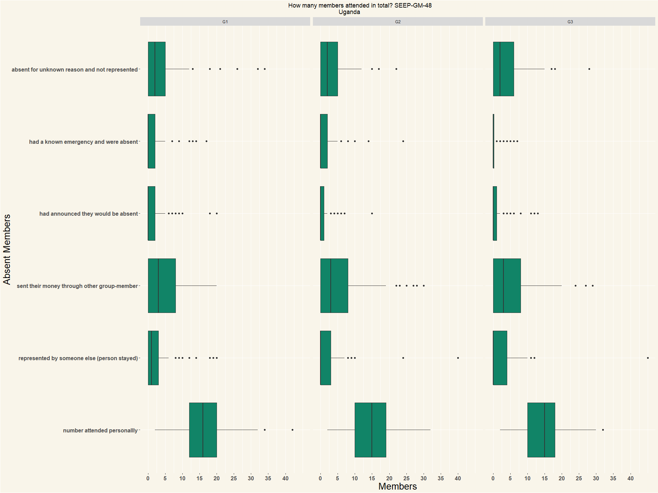

## [1] "Mali"

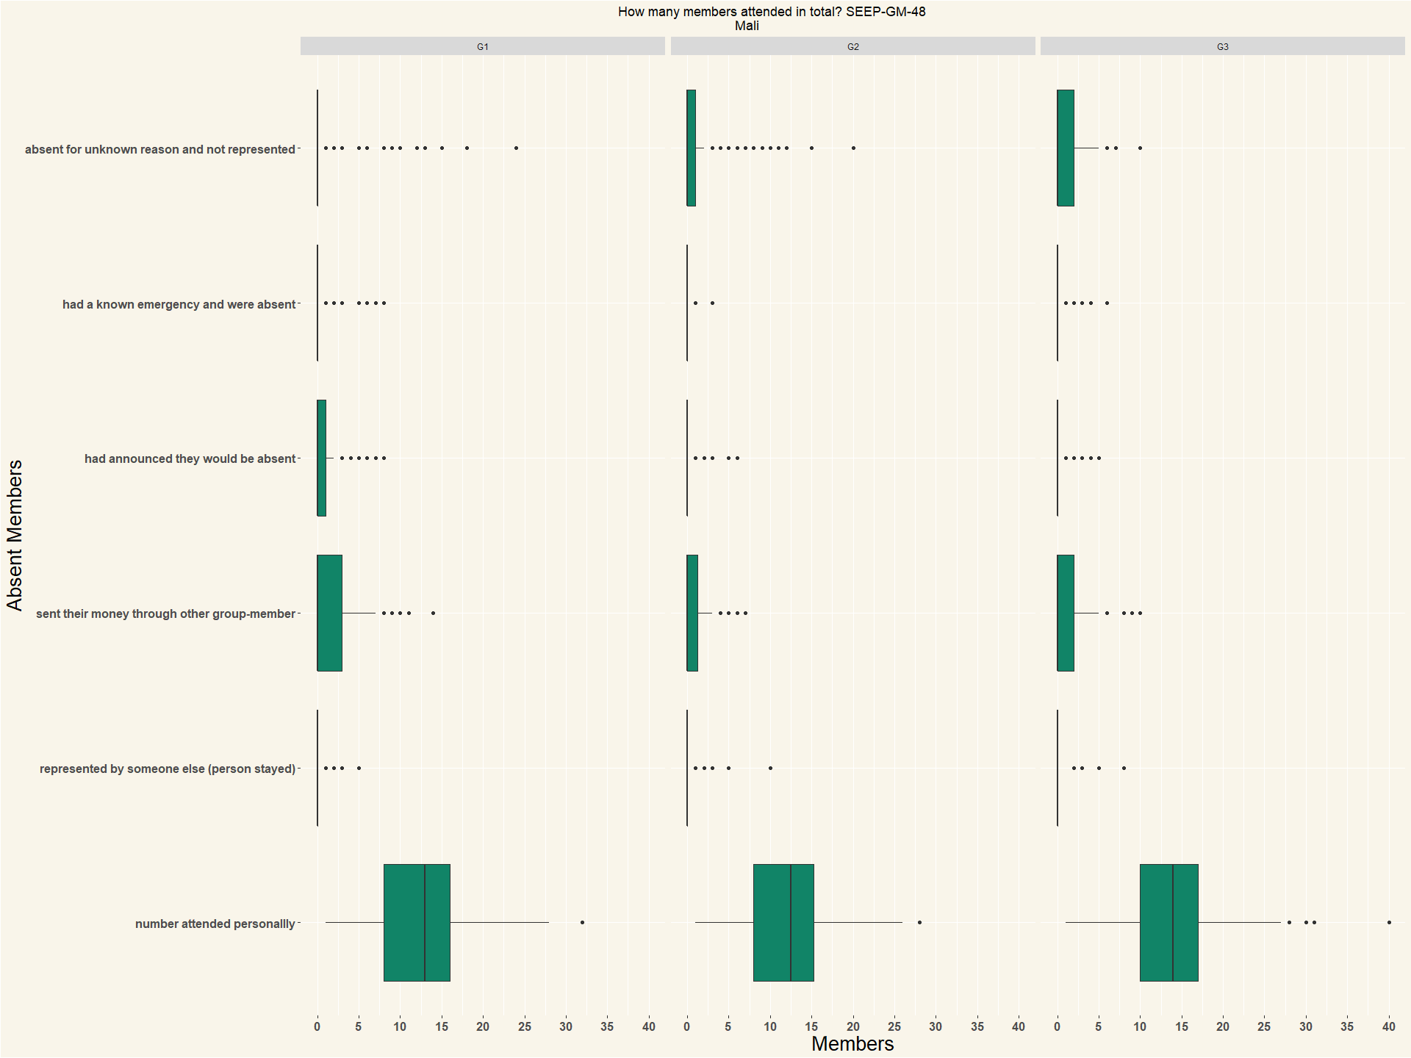

|  |  |  |  |
| --- | --- | --- | --- |
| Country | G1 | G2 | G3 |
| Mali | 152 | 152 | 152 |
| Uganda | 141 | 143 | 136 |
| [](Meetin | g_file | s/figu | re-docx/unnamed-chunk-46-1.png) |

# Q49 How many members arrived after meeting started?

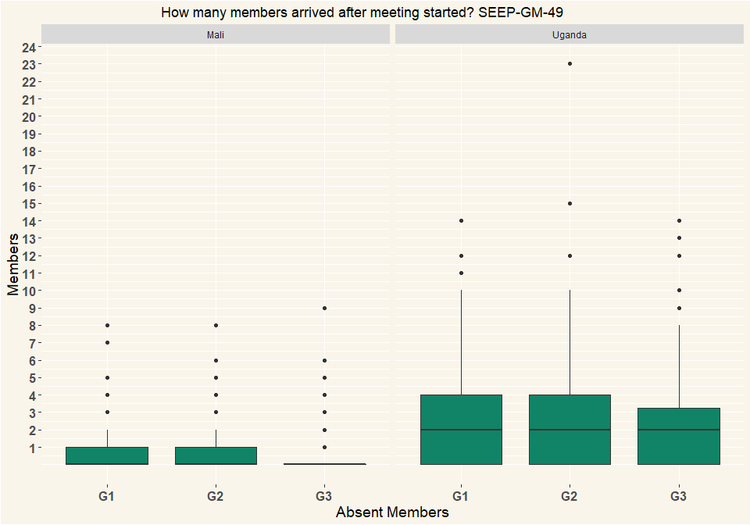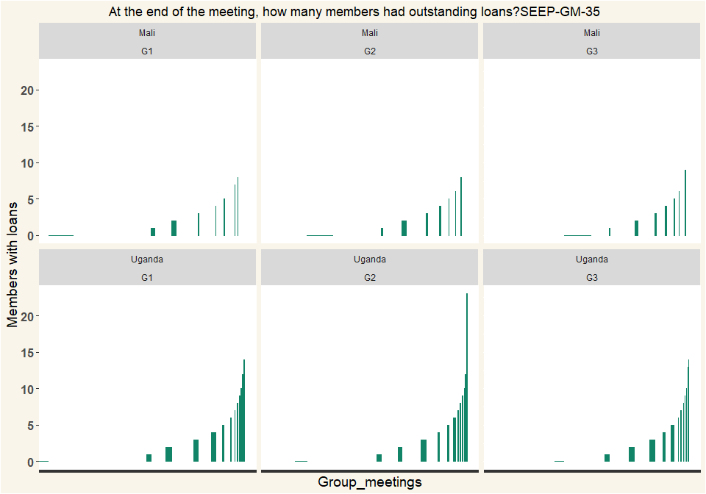

|  |  |  |  |
| --- | --- | --- | --- |
| Country | G1 | G2 | G3 |
| Mali | 152 | 152 | 152 |
| Uganda | 141 | 143 | 136 |

# Q50 Has the group experienced any of the following since last meeting up to end of this meeting? (Multiple Selection)

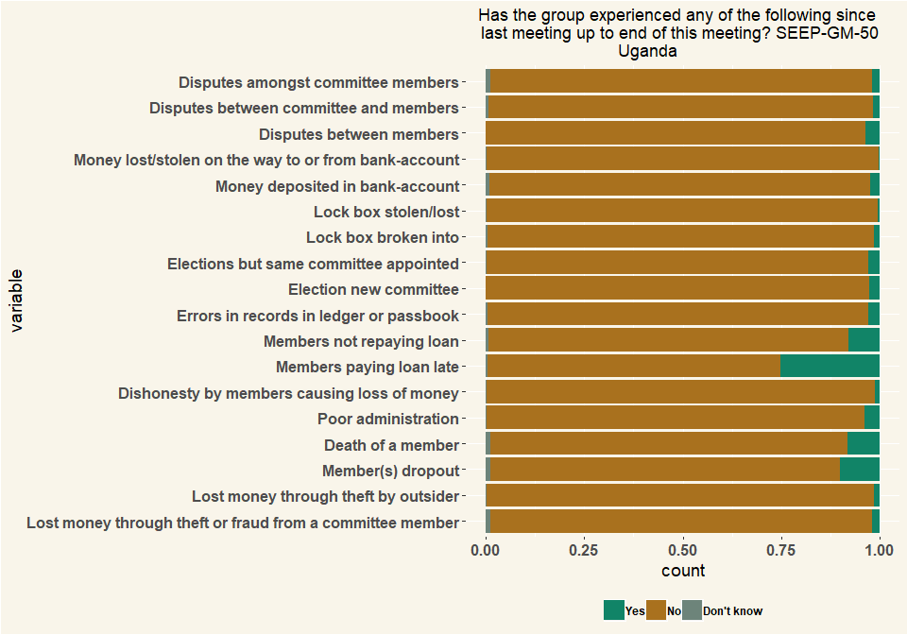

|  |  |  |  |
| --- | --- | --- | --- |
| Country | G1 | G2 | G3 |
| Mali | 152 | 152 | 152 |
| Uganda | 141 | 143 | 136 |

# Q51 Was any of the following used at the group-meeting? (Multiple Choice)

|  |  |  |  |  |  |  |
| --- | --- | --- | --- | --- | --- | --- |
| variable | Mali_G1 | Mali_G2 | Mali_G3 | Uganda_G1 | Uganda_G2 | Uganda_G3 |
| Calculator on phone | 2 | 3 | 871 | 112 | 118 | 177 |
| Separate calculator | 27 | 26 | 2 | 48 | 60 | 58 |
| App on phone including e-recording | 0 | 0 | 0 | 0 | 0 | 0 |
| Tablet or computer | 0 | 0 | 0 | 0 | 0 | 0 |
| Mobile money | 0 | 0 | 0 | 0 | 0 | 0 |
| eWallet | 0 | 0 | 0 | 0 | 0 | 0 |
| None | 124 | 124 | 0 | 9 | 4 | 0 |
| Respondents | 153 | 153 | 873 | 169 | 182 | 235 |

|  |  |  |  |  |  |  |
| --- | --- | --- | --- | --- | --- | --- |
| variable | Mali_G1 | Mali_G2 | Mali_G3 | Uganda_G1 | Uganda_G2 | Uganda_G3 |
| Calculator on phone | 0.0131 | 0.0196 | 0.998 | 0.663 | 0.648 | 0.753 |
| Separate calculator | 0.176 | 0.17 | 0.00229 | 0.284 | 0.33 | 0.247 |
| App on phone including e-recording | 0 | 0 | 0 | 0 | 0 | 0 |
| Tablet or computer | 0 | 0 | 0 | 0 | 0 | 0 |
| Mobile money | 0 | 0 | 0 | 0 | 0 | 0 |
| eWallet | 0 | 0 | 0 | 0 | 0 | 0 |
| None | 0.81 | 0.81 | 0 | 0.0533 | 0.022 | 0 |
| Percentage | 1 | 1 | 1 | 1 | 1 | 1 |

## Individual Questions Group Meeting 2

# Q_52 M2What type of relationship(s) does the group have with a financial service provider? (Multiple Selection)

|  |  |  |
| --- | --- | --- |
| variable | Mali | Uganda |
| Individual group members have accounts (unrelated to the group) | 6 | 34 |
| Individual group members have loans (unrelated to the group, group not guaranteeing loan) | 6 | 22 |
| Individual group members have accounts as a result of the group | 1 | 3 |
| Individual group members have loans, related to the group, group guaranteeing loan or member’s track record helping to get the loan | 0 | 0 |
| Group has an account (e.g. for excess funds) | 6 | 25 |
| Group has a loan from financial service provider | 1 | 9 |
| I don’t know | 0 | 0 |
| I don’t want to answer | 0 | 0 |
| NA | 20 | 93 |

|  |  |  |
| --- | --- | --- |
| variable | Mali | Uganda |
| Individual group members have accounts (unrelated to the group) | 0.3 | 0.366 |
| Individual group members have loans (unrelated to the group, group not guaranteeing loan) | 0.3 | 0.237 |
| Individual group members have accounts as a result of the group | 0.05 | 0.0323 |
| Individual group members have loans, related to the group, group guaranteeing loan or member’s track record helping to get the loan | 0 | 0 |
| Group has an account (e.g. for excess funds) | 0.3 | 0.269 |
| Group has a loan from financial service provider | 0.05 | 0.0968 |
| I don’t know | 0 | 0 |
| I don’t want to answer | 0 | 0 |
| NA | 1 | 1 |

# 53 Does the group have an account

|  |  |  |
| --- | --- | --- |
| Q_53 | Mali | Uganda |
| Yes | 10 | 24 |
| No | 140 | 118 |
| I don’t know | 2 | 1 |
| Respondents | 152 | 143 |

|  |  |  |
| --- | --- | --- |
| Q_53 | Mali | Uganda |
| Yes | 0.0658 | 0.168 |
| No | 0.921 | 0.825 |
| I don’t know | 0.0132 | 0.00699 |
| Percentage | 1 | 1 |

# 54 In what type of institution does the group have an account?

|  |  |  |
| --- | --- | --- |
| variable | Mali | Uganda |
| Commercial Bank | 3 | 7 |
| MDIs | 1 | 0 |
| MFIs | 8 | 3 |
| Credit institutions | 1 | 1 |
| SACCOs | 0 | 13 |
| MNO (mobile money) | 0 | 0 |
| Other (specify) | 1 | 0 |
| I don’t want to answer | 0 | 0 |
| NA | 14 | 24 |

|  |  |  |
| --- | --- | --- |
| variable | Mali | Uganda |
| Commercial Bank | 0.214 | 0.292 |
| MDIs | 0.0714 | 0 |
| MFIs | 0.571 | 0.125 |
| Credit institutions | 0.0714 | 0.0417 |
| SACCOs | 0 | 0.542 |
| MNO (mobile money) | 0 | 0 |
| Other (specify) | 0.0714 | 0 |
| I don’t want to answer | 0 | 0 |
| NA | 1 | 1 |

# 55 How did the group obtain the {0} account?

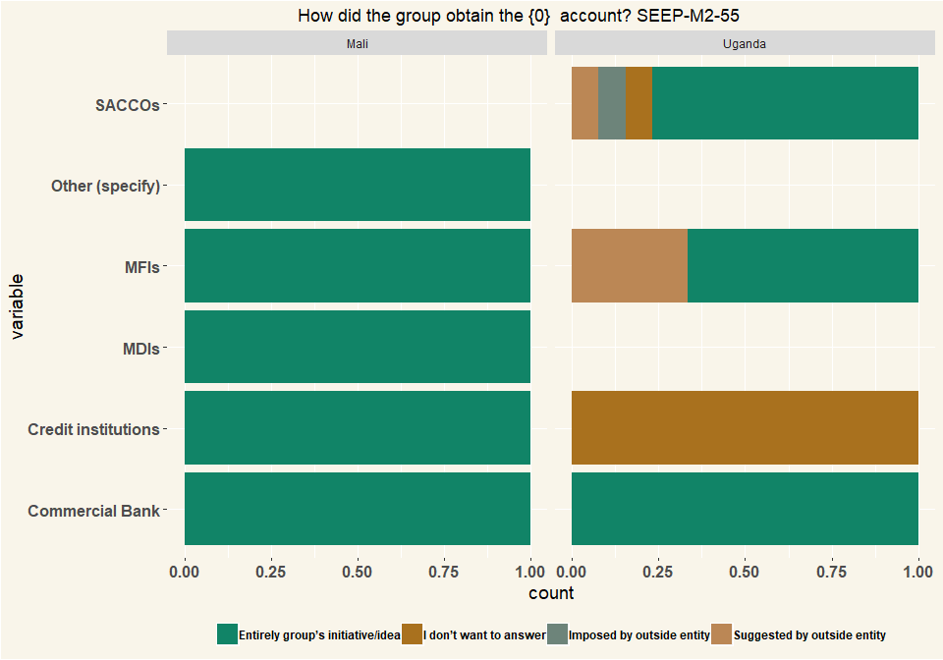

## # A tibble: 2 x 2  
## # Groups: Country [2]  
## Country n  
## <chr> <int>  
## 1 Mali 14  
## 2 Uganda 24

# 56 For what is the {0} account used for the group?

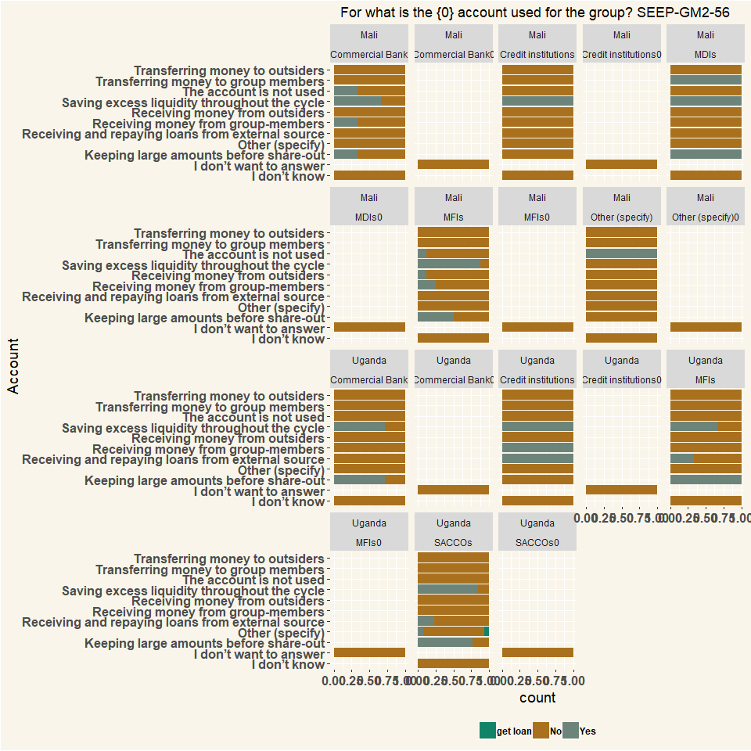

## # A tibble: 2 x 2  
## # Groups: Country [2]  
## Country n  
## <chr> <int>  
## 1 Mali 154  
## 2 Uganda 265

# 57 For what is the {0} account used by the members?

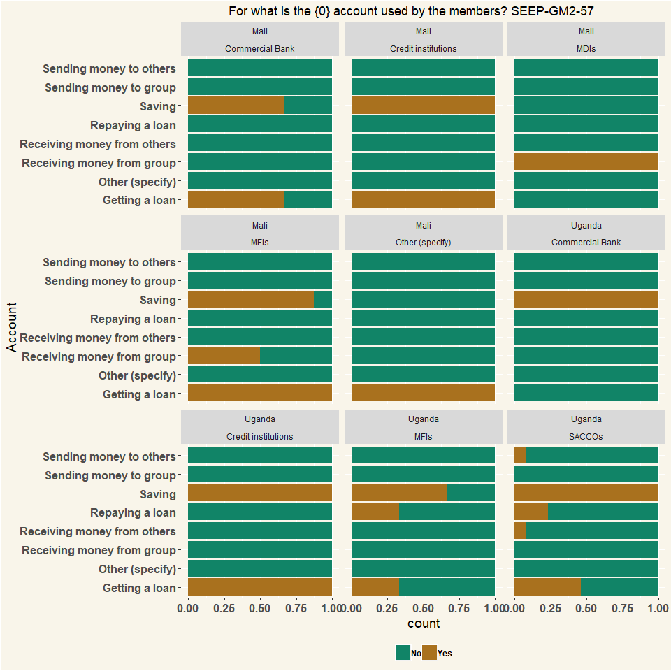

## # A tibble: 2 x 2  
## # Groups: Country [2]  
## Country n  
## <chr> <int>  
## 1 Mali 112  
## 2 Uganda 192

#58 Has your group considered using the services of a Financial Service Provider

* No response in this question

# 59 Why doesn’t your group have an account?

* No response in this Question

# 60 Which financial services would be useful for your group? Open an account

* No response on this question as well

# Q61 Does the group use mobile money?

|  |  |  |
| --- | --- | --- |
| Q_61 | Mali | Uganda |
| Yes | 2 | 2 |
| No | 150 | 139 |
| I don’t know | 0 | 1 |
| I don’t want to answer | 0 | 1 |
| Respondents | 152 | 143 |

|  |  |  |
| --- | --- | --- |
| Q_61 | Mali | Uganda |
| Yes | 0.0132 | 0.014 |
| No | 0.987 | 0.972 |
| I don’t know | 0 | 0.00699 |
| I don’t want to answer | 0 | 0.00699 |
| Percentage | 1 | 1 |

# 63 Do group members use mobile money? (Multiple Selection)

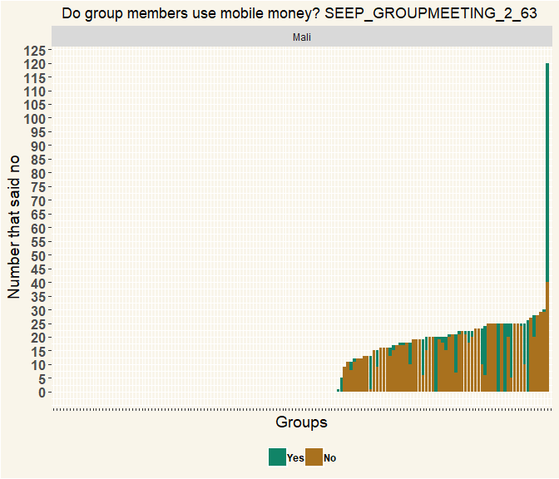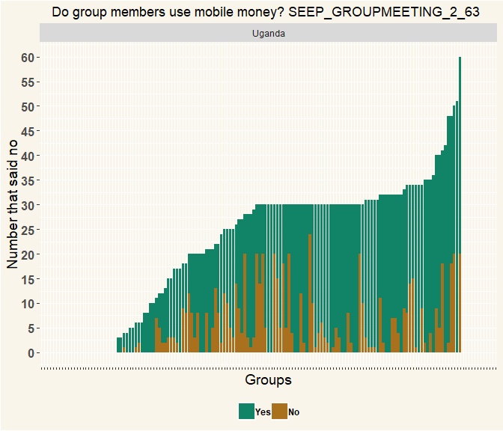

|  |  |  |  |
| --- | --- | --- | --- |
| Country | variable | Median | Mean |
| Mali | Yes | 5 | 9.971429 |
| Mali | No | 18 | 17.508475 |
| Uganda | Yes | 22 | 21.000000 |
| Uganda | No | 5 | 7.726191 |

|  |  |
| --- | --- |
| Country | n |
| Mali | 152 |
| Uganda | 143 |

# Q64 What is mobile money used for by the members? (Multiple Selection)

|  |  |  |
| --- | --- | --- |
| variable | Mali | Uganda |
| Saving | 7 | 44 |
| Sending money to group | 6 | 20 |
| Sending money to others | 12 | 80 |
| Receiving money from group | 7 | 18 |
| Receiving money from others | 40 | 95 |
| Getting a loan | 2 | 19 |
| Repaying a loan | 0 | 16 |
| Other (specify) | 101 | 36 |
| Respondents | 152 | 143 |

|  |  |  |
| --- | --- | --- |
| variable | Mali | Uganda |
| Saving | 0.04 | 0.134 |
| Sending money to group | 0.0343 | 0.061 |
| Sending money to others | 0.0686 | 0.244 |
| Receiving money from group | 0.04 | 0.0549 |
| Receiving money from others | 0.229 | 0.29 |
| Getting a loan | 0.0114 | 0.0579 |
| Repaying a loan | 0 | 0.0488 |
| Other (specify) | 0.577 | 0.11 |
| Percentage | 1 | 1 |

## Mobile_money_use count  
## 1 None 105  
## 2 I dont Know 21  
## 3 Buying Airtime 2  
## 4 Personal Use 4  
## 5 Poverty 1  
## 6 Sending and Receiving from distant relatives 1  
## 7 To pay school fees 1  
## 8 <NA> 135

# 65 How many members have a smart phone that they can use when they need it? (Mutiple Selection)

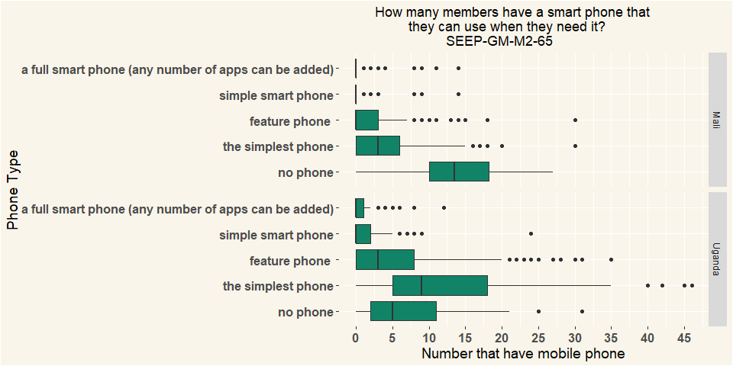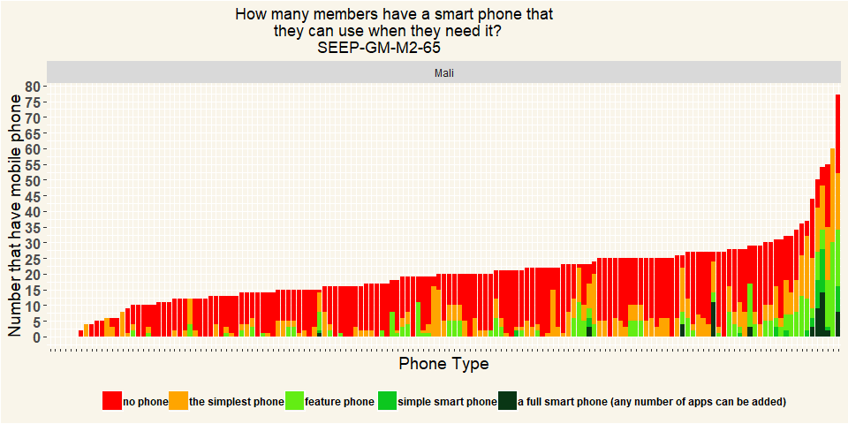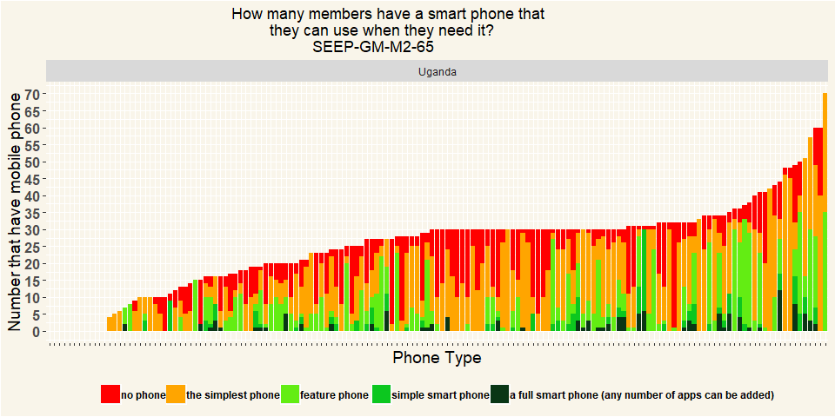

|  |  |
| --- | --- |
| Country | n |
| Mali | 152 |
| Uganda | 143 |

# 66 Does this VSLA group have relationships with the following type of organisations? (Multiple Selection)

|  |  |  |
| --- | --- | --- |
| variable | Mali | Uganda |
| NGOs | 5 | 28 |
| CBOs | 7 | 6 |
| Government agencies | 1 | 5 |
| Religious institutions (mosque, church, …) | 2 | 4 |
| Political party | 1 | 5 |
| Private company | 0 | 4 |
| Other (specify) | 0 | 0 |
| None | 137 | 105 |
| Does not want to answer | 0 | 1 |
| Respondents | 152 | 143 |

|  |  |  |
| --- | --- | --- |
| variable | Mali | Uganda |
| NGOs | 0.0327 | 0.177 |
| CBOs | 0.0458 | 0.038 |
| Government agencies | 0.00654 | 0.0316 |
| Religious institutions (mosque, church, …) | 0.0131 | 0.0253 |
| Political party | 0.00654 | 0.0316 |
| Private company | 0 | 0.0253 |
| Other (specify) | 0 | 0 |
| None | 0.895 | 0.665 |
| Does not want to answer | 0 | 0.00633 |
| Percentage | 1 | 1 |

# 67 What type of relationship exist with {0} ?

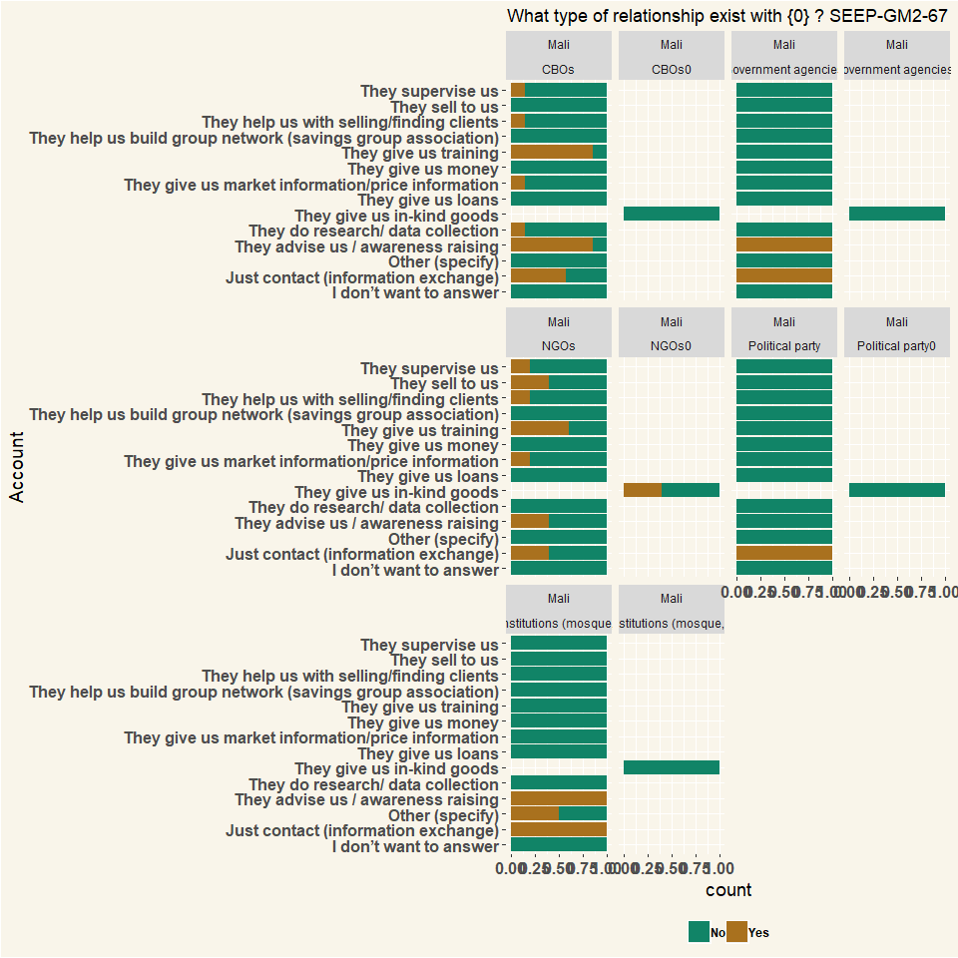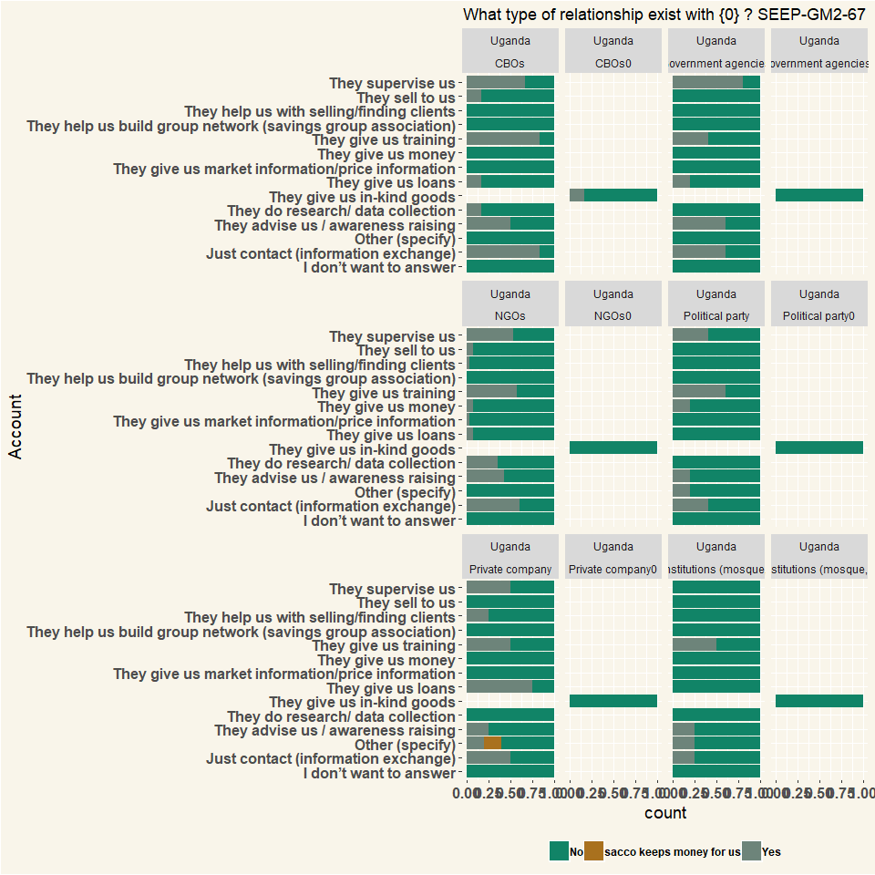

## # A tibble: 2 x 2  
## # Groups: Country [2]  
## Country n  
## <chr> <int>  
## 1 Mali 224  
## 2 Uganda 729

# 68 When was the most recent contact with the {0} ?

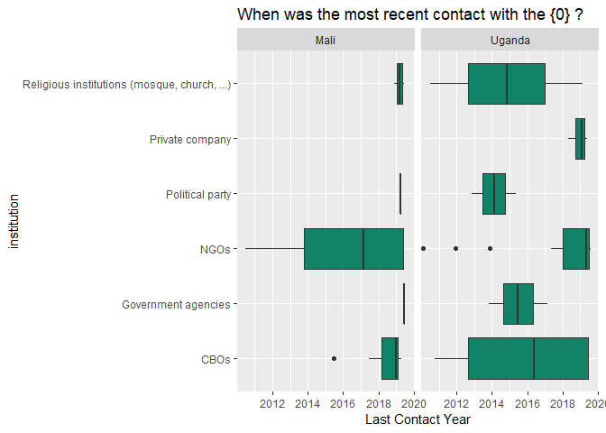

## # A tibble: 2 x 2  
## # Groups: Country [2]  
## Country n  
## <chr> <int>  
## 1 Mali 15  
## 2 Uganda 29

# 69 How satisfied are you with this relationship with the {0} ?

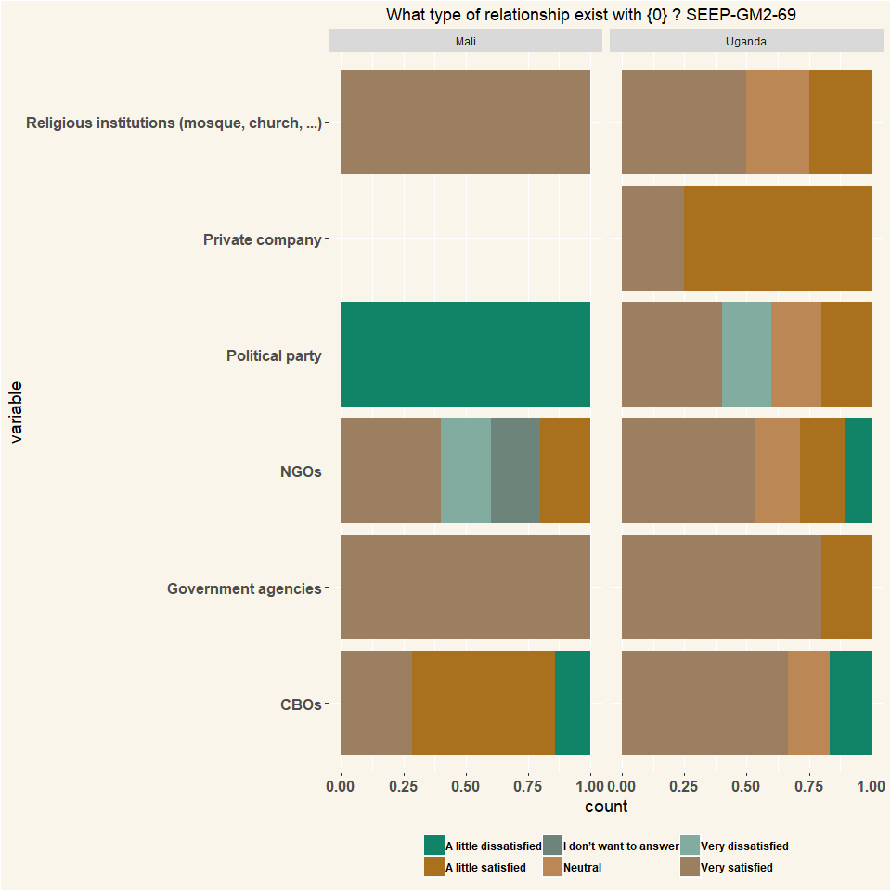

## # A tibble: 2 x 2  
## # Groups: Country [2]  
## Country n  
## <chr> <int>  
## 1 Mali 16  
## 2 Uganda 52

# Q70 Is the group registered with any local authority? E.g. with the municipality, ministry of cooperatives, chamber of commerce, etc.

|  |  |  |
| --- | --- | --- |
| var | Mali | Uganda |
| Yes | 25 | 79 |
| No | 107 | 56 |
| I don’t know | 20 | 8 |
| Respondents | 152 | 143 |

|  |  |  |
| --- | --- | --- |
| var | Mali | Uganda |
| Yes | 0.164 | 0.552 |
| No | 0.704 | 0.392 |
| I don’t know | 0.132 | 0.0559 |
| Percentage | 1 | 1 |

# 71 Why is the group registered?

|  |  |  |
| --- | --- | --- |
| var | Mali | Uganda |
| It is an obligation from the government | 1 | 22 |
| We wanted to formalize our group / we wanted to register | 9 | 49 |
| We needed the registration for getting a bank account | 4 | 3 |
| We needed the registration for something else | 11 | 3 |
| Other (specify) | 0 | 2 |
| Respondents | 25 | 79 |

|  |  |  |
| --- | --- | --- |
| var | Mali | Uganda |
| It is an obligation from the government | 0.04 | 0.278 |
| We wanted to formalize our group / we wanted to register | 0.36 | 0.62 |
| We needed the registration for getting a bank account | 0.16 | 0.038 |
| We needed the registration for something else | 0.44 | 0.038 |
| Other (specify) | 0 | 0.0253 |
| Percentage | 1 | 1 |

# 72 At which office did you register the group?

|  |  |  |
| --- | --- | --- |
| var | Mali | Uganda |
| Department/Ministry of cooperatives | 1 | 22 |
| Townhall | 9 | 49 |
| Chamber of Commerce | 4 | 3 |
| Mosque/church | 11 | 3 |
| Other (specify) | 0 | 2 |
| Respondents | 25 | 79 |

|  |  |  |
| --- | --- | --- |
| var | Mali | Uganda |
| Department/Ministry of cooperatives | 0.04 | 0.278 |
| Townhall | 0.36 | 0.62 |
| Chamber of Commerce | 0.16 | 0.038 |
| Mosque/church | 0.44 | 0.038 |
| Other (specify) | 0 | 0.0253 |
| Percentage | 1 | 1 |

# 73 Did it cost any money to register?

|  |  |  |
| --- | --- | --- |
| var | Mali | Uganda |
| Yes | 22 | 67 |
| No | 3 | 12 |
| Respondents | 25 | 79 |

|  |  |  |
| --- | --- | --- |
| var | Mali | Uganda |
| Yes | 0.88 | 0.848 |
| No | 0.12 | 0.152 |
| Percentage | 1 | 1 |

# 74 How much did the registration cost?

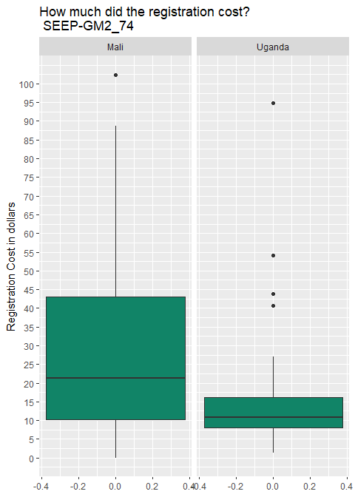

## # A tibble: 2 x 2  
## # Groups: Country [2]  
## Country n  
## <chr> <int>  
## 1 Mali 22  
## 2 Uganda 67

# 75 What are the benefits of registration?

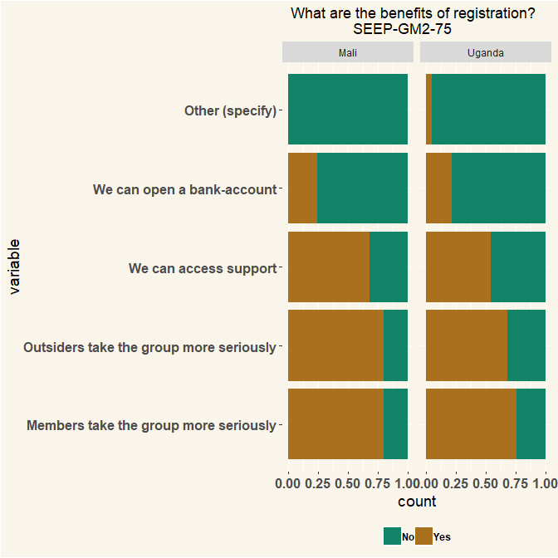

## # A tibble: 5 x 2  
## # Groups: others [5]  
## others n  
## <chr> <int>  
## 1 if a member fails to pay back the loan the group has capacity to s~ 1  
## 2 maybe in future we shall access support from Gorvrment or NGOs 1  
## 3 we are aknown group 1  
## 4 we need to be remembered incase governments wants to help people a~ 1  
## 5 what if someone fails to pay,they can be helped and whenever gorve~ 1

# 76 Does the group still receive any type of training or information sessions from the original trainer/facilitating NGO?

|  |  |  |
| --- | --- | --- |
| var | Mali | Uganda |
| Yes | 6 | 17 |
| No | 146 | 126 |
| Respondents | 152 | 143 |

|  |  |  |
| --- | --- | --- |
| var | Mali | Uganda |
| Yes | 0.0395 | 0.119 |
| No | 0.961 | 0.881 |
| Percentage | 1 | 1 |

# 77 What type of support/training/information?

## # A tibble: 22 x 2  
## # Groups: var [22]  
## var n  
## <chr> <int>  
## 1 At share out process 1  
## 2 autonomisation des femmes 1  
## 3 conflict resolution 1  
## 4 Encouraging members to keep saving 1  
## 5 exchange of knowledge 1  
## 6 formation 1  
## 7 formation sur le maresage et alphabétisation 1  
## 8 he comes and count money for them at the end of year when they sh~ 1  
## 9 he comes and count money when they are sharing at the end of year 1  
## 10 He is the one who share out at the end of cycle 1  
## # ... with 12 more rows

# Q78 Does the VSLA group have any joint economic activity?

|  |  |  |
| --- | --- | --- |
| Q_79 | Mali | Uganda |
| Yes | 25 | 10 |
| No | 126 | 131 |
| I don’t know | 1 | 2 |
| NA | 152 | 143 |

|  |  |  |
| --- | --- | --- |
| Q_79 | Mali | Uganda |
| Yes | 0.164 | 0.0699 |
| No | 0.829 | 0.916 |
| I don’t know | 0.00658 | 0.014 |
| Percentage | 1 | 1 |

# 79 If so, please describe what these joint economic activities are?

|  |  |  |
| --- | --- | --- |
| Q_79 | Mali | Uganda |
| Joint production | 13 | 4 |
| Bulk purchases of inputs | 2 | 2 |
| Bulk selling/Joint marketing of output | 6 | NA |
| Group business | NA | 4 |
| Other (specify) | 4 | NA |
| NA | 25 | 10 |

|  |  |  |
| --- | --- | --- |
| Q_79 | Mali | Uganda |
| Joint production | 0.52 | 0.4 |
| Bulk purchases of inputs | 0.08 | 0.2 |
| Bulk selling/Joint marketing of output | 0.24 | NA |
| Group business | NA | 0.4 |
| Other (specify) | 0.16 | NA |
| Percentage | 1 | 1 |

## # A tibble: 3 x 2  
## # Groups: Others [3]  
## Others n  
## <chr> <int>  
## 1 achat et revend du riz 1  
## 2 les travaux champêtre 2  
## 3 travaux champêtre 1

# 80 For each activity, does the whole group do it together, or only some of the members?

|  |  |  |
| --- | --- | --- |
| Q_79 | Mali | Uganda |
| Yes, as the whole group together | 27 | 10 |
| Yes, but only part of the group | 3 | 4 |
| No | 20 | 15 |
| I don’t know | 1 | NA |
| I don’t want to answer | NA | 1 |
| NA | 51 | 30 |

|  |  |  |
| --- | --- | --- |
| Q_79 | Mali | Uganda |
| Yes, as the whole group together | 0.529 | 0.333 |
| Yes, but only part of the group | 0.0588 | 0.133 |
| No | 0.392 | 0.5 |
| I don’t know | 0.0196 | NA |
| I don’t want to answer | NA | 0.0333 |
| Percentage | 1 | 1 |

# 81 Do the members trade with each other / provide each other business / refer customers to each other?

|  |  |  |
| --- | --- | --- |
| Q_81 | Mali | Uganda |
| Yes | 57 | 45 |
| No | 94 | 96 |
| I don’t know | 1 | 2 |
| NA | 152 | 143 |

|  |  |  |
| --- | --- | --- |
| Q_81 | Mali | Uganda |
| Yes | 0.375 | 0.315 |
| No | 0.618 | 0.671 |
| I don’t know | 0.00658 | 0.014 |
| Percentage | 1 | 1 |

# 82 Does the group have any other form of innovation?

|  |  |  |
| --- | --- | --- |
| Q_82 | Mali | Uganda |
| Yes | 30 | 13 |
| No | 117 | 125 |
| I don’t know | 5 | 4 |
| I don’t want to answer | NA | 1 |
| Respondents | 152 | 143 |

|  |  |  |
| --- | --- | --- |
| Q_82 | Mali | Uganda |
| Yes | 0.197 | 0.0909 |
| No | 0.77 | 0.874 |
| I don’t know | 0.0329 | 0.028 |
| I don’t want to answer | NA | 0.00699 |
| Percentage | 1 | 1 |

# 83 Are there women in local government (commune level)?

|  |  |  |
| --- | --- | --- |
| Q_83 | Mali | Uganda |
| Yes, several | 2 | 25 |
| Yes, one | 15 | 44 |
| No, none | 135 | 68 |
| I don’t know | NA | 5 |
| Does not want to answer | NA | 1 |
| NA | 152 | 143 |

|  |  |  |
| --- | --- | --- |
| Q_83 | Mali | Uganda |
| Yes, several | 0.0132 | 0.175 |
| Yes, one | 0.0987 | 0.308 |
| No, none | 0.888 | 0.476 |
| I don’t know | NA | 0.035 |
| Does not want to answer | NA | 0.00699 |
| Percentage | 1 | 1 |

# 84 Are these elected women member of a VSLA savings group?

|  |  |  |
| --- | --- | --- |
| Q_84 | Mali | Uganda |
| Yes, all | 2 | 5 |
| Yes, some/one | NA | 13 |
| No, none | NA | 6 |
| I don’t know | NA | 1 |
| NA | 2 | 25 |

|  |  |  |
| --- | --- | --- |
| Q_84 | Mali | Uganda |
| Yes, all | 1 | 0.2 |
| Yes, some/one | NA | 0.52 |
| No, none | NA | 0.24 |
| I don’t know | NA | 0.04 |
| Percentage | 1 | 1 |

# 85 Is this elected woman member of a VSLA savings group that was formed by SaveUp or Banking on Change?

|  |  |  |
| --- | --- | --- |
| Q_85 | Mali | Uganda |
| Yes | 7 | 22 |
| No | 6 | 21 |
| I don’t know | 2 | 1 |
| Respondents | 15 | 44 |

|  |  |  |
| --- | --- | --- |
| Q_85 | Mali | Uganda |
| Yes | 0.467 | 0.5 |
| No | 0.4 | 0.477 |
| I don’t know | 0.133 | 0.0227 |
| Percentage | 1 | 1 |

# 86 Do you think their/her election is related to VSLA saving group membership?

|  |  |  |
| --- | --- | --- |
| Q_86 | Mali | Uganda |
| Yes, due to savings groups she got elected | 7 | 37 |
| No, there is no connection | 7 | 24 |
| I don’t know | 3 | 8 |
| NA | 17 | 69 |

|  |  |  |
| --- | --- | --- |
| Q_86 | Mali | Uganda |
| Yes, due to savings groups she got elected | 0.412 | 0.536 |
| No, there is no connection | 0.412 | 0.348 |
| I don’t know | 0.176 | 0.116 |
| Percentage | 1 | 1 |

# 87 How did the VSLA savings group membership help the election? (Multiple Selection)

|  |  |  |
| --- | --- | --- |
| variable | Mali | Uganda |
| She/they got confidence because of the SFC savings group so dared to be nominated | 7 | 21 |
| She/they got skills because of the SFC groups, so knew how to convince voters | 1 | 26 |
| She/they got all the votes from the SFC savings groups | 2 | 22 |
| She/they learned in the SFC savings group that it is important women get elected | 1 | 6 |
| Other (specify) | 0 | 1 |
| NA | 11 | 76 |

|  |  |  |
| --- | --- | --- |
| variable | Mali | Uganda |
| She/they got confidence because of the SFC savings group so dared to be nominated | 0.636 | 0.276 |
| She/they got skills because of the SFC groups, so knew how to convince voters | 0.0909 | 0.342 |
| She/they got all the votes from the SFC savings groups | 0.182 | 0.289 |
| She/they learned in the SFC savings group that it is important women get elected | 0.0909 | 0.0789 |
| Other (specify) | 0 | 0.0132 |
| Percentage | 1 | 1 |

|  |  |
| --- | --- |
| Other | n |
| auccune femme dans l’administration | 1 |
| aucune | 6 |
| aucunee | 1 |
| aucunee femme | 9 |
| aucunee femme dans l’administration | 7 |
| aucunee femme dans l’administration locale | 2 |
| aucunee personnes dans l’administration locale | 1 |
| doesn’t want to answer | 1 |
| don’t know | 1 |
| elle ne ce fait pas confiance | 1 |
| elle son moins impliqué dans les processus d’élections | 1 |
| elle son moins impliqué dans les procesus electoraux | 1 |
| elles ne sont pas impliquées dans les instances de no member is in local governmentestion de pouvoir | 1 |
| elles participent moins aux activités politiques | 1 |
| elles participent moins aux élections | 1 |
| elles participent moins dans les politiques | 1 |
| elles sont impliquées dans les instances de ladministration | 1 |
| elles sont moins associées aux politiques | 1 |
| elles sont moins impliquées dans la politique | 2 |
| elles sont moins impliquées dans la prise de décision | 1 |
| elles sont moins impliquées dans les decisions politiques | 1 |
| elles sont moins impliquées dans les instances | 1 |
| elles sont moins impliquées dans les instances politiques | 1 |
| elles sont moins impliquées dans les prises de décisions | 1 |
| i do not know. | 1 |
| i dont know | 2 |
| its nothinno member is in local government | 1 |
| je sais pas | 1 |
| le no member is in local governmentroupe ne participe pas au processus électoral | 3 |
| les membres du ne participe pas au processus électoral | 1 |
| les membres du no member is in local governmentroupe ne participe pas au processus électoral | 9 |
| les membres ne participe pas au processus électoral | 7 |
| ne sais pas | 9 |
| neant | 1 |
| néant | 7 |
| never heard of it | 1 |
| no applicable | 1 |
| no connection at all | 1 |
| no member is in local government | 51 |
| no member is in local government is in local no member is in local governmentovernment | 1 |
| no member is in local governmentr | 1 |
| no women in the local no member is in local governmentovernment | 1 |
| nothinno member is in local government | 11 |
| ont sais pas | 1 |
| pas de femme | 1 |
| pas de femme dans l’administration locale | 10 |
| pas de rapport | 1 |
| personne | 1 |
| rien | 1 |
| she from uweso not sfc | 1 |
| she was just popular already | 1 |
| we cant tell | 1 |
| women also active and they can participate in politics,they can talk they dont fear people | 1 |

# 88 What are other motivations for joining VSLA group apart from savings? (Multiple Selection)

|  |  |  |
| --- | --- | --- |
| variable | Mali | Uganda |
| Social/being with friends | 141 | 110 |
| Learning skills | 81 | 91 |
| Organizing women to be strong together | 83 | 69 |
| Possibility to get loan | 83 | 103 |
| Possibility to do a business as a group | 61 | 39 |
| Selling goods to others | 20 | 21 |
| Other (specify) | 2 | 6 |
| Respondents | 152 | 143 |

|  |  |  |
| --- | --- | --- |
| variable | Mali | Uganda |
| Social/being with friends | 0.299 | 0.251 |
| Learning skills | 0.172 | 0.207 |
| Organizing women to be strong together | 0.176 | 0.157 |
| Possibility to get loan | 0.176 | 0.235 |
| Possibility to do a business as a group | 0.13 | 0.0888 |
| Selling goods to others | 0.0425 | 0.0478 |
| Other (specify) | 0.00425 | 0.0137 |
| Percentage | 1 | 1 |

## Individual Questions Group Meeting 3

# Q51 Do you have a written constitution?

|  |  |  |
| --- | --- | --- |
| value | Mali | Uganda |
| Yes | 9 | 80 |
| No | 143 | 49 |
| Other (specify) | 0 | 7 |
| Respondents | 152 | 136 |

|  |  |  |
| --- | --- | --- |
| value | Mali | Uganda |
| Yes | 0.0592 | 0.588 |
| No | 0.941 | 0.36 |
| Other (specify) | 0 | 0.0515 |
| Percentage | 1 | 1 |

# Q53 Since the group was formed, have you changed any of the rules, or adopted new rules?

|  |  |  |
| --- | --- | --- |
| value | Mali | Uganda |
| Yes | 103 | 55 |
| No | 49 | 81 |
| Respondents | 152 | 136 |

|  |  |  |
| --- | --- | --- |
| value | Mali | Uganda |
| Yes | 0.678 | 0.404 |
| No | 0.322 | 0.596 |
| Percentage | 1 | 1 |

# Q54 Which rules were changed? (Multiple Selection)

* No “Others” details for this question

|  |  |  |
| --- | --- | --- |
| variable | Mali | Uganda |
| Savings amount | 88 | 25 |
| Share amount | 3 | 25 |
| Loan amount | 7 | 2 |
| Loan interest | 7 | 10 |
| Loan duration | 19 | 6 |
| Loan eligibility | 0 | 4 |
| Social Fund | 0 | 15 |
| Fine | 25 | 19 |
| Other (specify) | 35 | 65 |
| Respondents | 152 | 136 |

|  |  |  |
| --- | --- | --- |
| variable | Mali | Uganda |
| Savings amount | 0.478 | 0.146 |
| Share amount | 0.0163 | 0.146 |
| Loan amount | 0.038 | 0.0117 |
| Loan interest | 0.038 | 0.0585 |
| Loan duration | 0.103 | 0.0351 |
| Loan eligibility | 0 | 0.0234 |
| Social Fund | 0 | 0.0877 |
| Fine | 0.136 | 0.111 |
| Other (specify) | 0.19 | 0.38 |
| Percentage | 1 | 1 |

# 55 What was changed?

## # A tibble: 159 x 2  
## # Groups: Others [159]  
## Others n  
## <chr> <int>  
## 1 1 mois a 2 mois avec un taux de 20% les 2 mois soit 10% l'an 1  
## 2 100 franc d'épargne a 250 franc 1  
## 3 "100f épargne est devenue 250f\r\nla durée du prêt de 4 semaines ~ 1  
## 4 250 au lieu de 100f comme epargne 1  
## 5 about loan duration 1  
## 6 amende ,durée des prêts 1  
## 7 amendes 1  
## 8 "amount of fine charged,\r\nincrease on the amount paid on social~ 1  
## 9 appelés les membres un à un 1  
## 10 at first the stamp was 1000 per now they changed each stump to 20~ 1  
## # ... with 149 more rows

# 56 What are the rules of your group?

## # A tibble: 233 x 2  
## # Groups: Others [233]  
## Others n  
## <chr> <int>  
## 1 -1 3  
## 2 "-no late coming\r\n-no arguments during the meeting.\r\n-no abse~ 1  
## 3 "-no late coming\r\n-no talking during the meeting\r\n-no rumours~ 1  
## 4 "-some of the rules are\r\n-no absentism\r\n-no late coming etc" 1  
## 5 "-to become amember one should not be renting.\r\n-chairperson an~ 1  
## 6 "1) late coming is prohibited \r\n2)talking during the meetings\r~ 1  
## 7 "10 % interest\r\na minimum of 1share\r\na maximum of 5shares" 1  
## 8 "2:00pm as sitting time \r\nfailing to attend for 2weeks fine is ~ 1  
## 9 "5per cent interrst \r\nwhen you miss saving 3 times you pay fin~ 1  
## 10 a member who doesn't save, paying loan late 1  
## # ... with 223 more rows

# 57 What are the rules for loan disbursement? (Multiple Selection)

|  |  |  |
| --- | --- | --- |
| variable | Mali | Uganda |
| Maximum loan size | 53 | 60 |
| Maximum loan size based on savings amount | 45 | 69 |
| Maximum loan duration | 75 | 81 |
| Interest rate | 127 | 106 |
| Taking turns in taking loans | 33 | 21 |
| Whether loan use is productive | 5 | 15 |
| Other (specify) | 20 | 8 |
| Respondents | 152 | 136 |

|  |  |  |
| --- | --- | --- |
| variable | Mali | Uganda |
| Maximum loan size | 0.148 | 0.167 |
| Maximum loan size based on savings amount | 0.126 | 0.192 |
| Maximum loan duration | 0.209 | 0.225 |
| Interest rate | 0.355 | 0.294 |
| Taking turns in taking loans | 0.0922 | 0.0583 |
| Whether loan use is productive | 0.014 | 0.0417 |
| Other (specify) | 0.0559 | 0.0222 |
| Percentage | 1 | 1 |

|  |  |
| --- | --- |
| Other | n |
| il nothing’y a pas régler pour les prêt des membres a part la méthodologie | 1 |
| le payemenothingt des inothingtérêts | 1 |
| les règles de la méthodologie | 1 |
| nothing | 5 |
| nothingéanothingt | 16 |
| nothingo rules | 1 |
| nothingothinothingg | 1 |
| they donothing’t give out loanothings | 1 |
| tout les membres onothingt droits au prêt | 1 |

# 58 Does your group sometimes not follow the rules? Can you give examples?

|  |  |
| --- | --- |
| Q_58 | n |
| amendé | 1 |
| at times | 1 |
| at times members fail to pay on time so we push them ahead | 1 |
| aucun | 1 |
| b | 1 |
| changed in loan duration | 1 |
| coming late | 2 |
| coming late and talking during meeting | 1 |
| failing to force members to pay late fee | 1 |
| failing to pay loans | 1 |
| fines are hardly given | 2 |
| fines are sometimes igno it follow rulesred | 1 |
| fines sometimes no it follow rulest given | 1 |
| ils respectent toutes les règles | 1 |
| l’absence no it follow rules justifiées | 1 |
| l’heure | 3 |
| l’heure de la réunion | 1 |
| l’heure de réunion | 1 |
| l’heure des réunions | 1 |
| l heure de réunion | 1 |
| l heure de réunion, les membres viennent en retar3 | 1 |
| l heure des réunions et le payement des amendes | 1 |
| l heure des réunions pendant les travaux champêtres et la cueillette des no it follow rulesix de karité | 1 |
| l heures de réunion | 1 |
| l heurr de réunion et le payements de la sanction du retard | 1 |
| l hzure de reunion et le payements des amendes | 1 |
| la duree des prêts | 1 |
| la participation a la reunion | 1 |
| la participation a la reunion | 1 |
| la présence a la reunion et le payements de l’épargne | 1 |
| la présence, l’heure | 1 |
| late coming | 3 |
| late coming is no it follow rulest followed | 1 |
| late coming no it follow rulest fined | 1 |
| late coming with a reason | 1 |
| late coming |  |
| changed loan duration from three money to entire cycle 1 |  |
| late coming, late payments of loan | 1 |
| le groupe ne respecte pas l’heure et ne participe pas tous a la reunion | 1 |
| le groupe respecte bien ces règles | 1 |
| le groupe respecte toute son règles | 2 |
| le groupe respecte toutes les règles | 1 |
| le murmure | 8 |
| le murmure le retard | 2 |
| le murmure retard | 1 |
| le murmure, retard | 1 |
| le murmure, souvent le retard | 1 |
| le payements des amendes | 2 |
| le retard | 1 |
| le retard le remboursement des pret dans le delais | 1 |
| le retard, le murmure | 1 |
| le retards | 1 |
| le retards des payement | 1 |
| le retards no it follow rules remboursements | 1 |
| les acis sont partagés | 1 |
| les amandes | 1 |
| les amendes | 8 |
| les amendes causées par le retard | 1 |
| les amendes pour la violations des règles | 1 |
| les amendes, les retards | 1 |
| les discussions lors de la réunion | 1 |
| les murmures | 6 |
| les murmures au moments de l’épargne | 1 |
| les murmures lors de la réunion | 1 |
| les respect de l heure de réunion | 1 |
| les retard | 1 |
| les retards | 2 |
| les retards et remboursements tarifs de prêts | 1 |
| les retards ne verser pas de l’épargne | 1 |
| les retards no it follow rules participation à la réunion | 1 |
| les retards parler lors de la réunion | 1 |
| les retards payement , lors de la réunion | 1 |
| les retards remboursement tarifs de prêts | 1 |
| les sanction | 1 |
| les sanctions ,payements obligatoires de l’epargne, le remboursement des pret avec intérêt | 1 |
| like no it follow rulest paying fine for late coming | 1 |
| loans sometimes are just given without checking person’s saving,, sometimes fines are no it follow rulest given | 1 |
| loans,, sometimes they just give whoever requests without checking savings | 1 |
| making no it follow rulesise during meeting | 1 |
| members at times come late and pay fines | 1 |
| members coming late | 1 |
| members coming late for the meeting | 1 |
| members pay loans with interest | 1 |
| members paying loans late |  |
| coming late for the meeting 1 |  |
| members who don’t attend the meeting are fined | 1 |
| n | 2 |
| neant | 1 |
| néant | 16 |
| never | 1 |
| nezt | 1 |
| no it follow rules | 43 |
| no it follow rules it follow rules | 1 |
| no it follow rules le groupe respecte bien les règles | 3 |
| no it follow rules le groupe respecte bien toutes ces règles | 4 |
| no it follow rules le groupe respecte bien toutes les règles | 4 |
| no it follow rules le respecte bien toutes les règles | 1 |
| no it follow rules le respecte tous les règles | 1 |
| no it follow rules no it follow rulesus respectons bien toutes no it follow ruless règles | 1 |
| no it follow rules no it follow rulesus respectons toutes no it follow ruless règles | 4 |
| no it follow rules rien | 1 |
| no it follow rules we follow | 1 |
| no it follow rules, some people still come for the meeting late | 1 |
| no it follow rules; tout les règles de la méthodologie sont respecté | 1 |
| no it follow rulest attending meeting, coming late. | 1 |
| no it follow rulest saving and abscent | 1 |
| no it follow rulest saving weekly | 1 |
| on respecte les amendes causées par le retard le no it follow rules-paiement de l’epargne | 1 |
| oui | 2 |
| oui,les amendes causées par le retard no it follow rules justifié de la reunion |  |
| , 1 |  |
| oui; les amendes | 1 |
| payements des amendes | 1 |
| paying fine | 1 |
| paying fine for paying loan late than the given period | 1 |
| quand un membre viole les règles plus de 2 fois il reçoit une mise en garde et d’il le fait une 3 ème fois il est exclut du groupe | 1 |
| remboursement tarifs de prêts | 1 |
| retard | 1 |
| rien | 1 |
| rules of no it follow rulesise making and coming late are no it follow rulest fined | 1 |
| some members dont want to pay fine for late coming | 1 |
| some people come late | 1 |
| some times we give a member aloan more than he/she has saved | 1 |
| sometimes members fail to pay loans in time | 1 |
| sometimes the loans duration is beyond the agreed time because time comes when a member fails to pay. | 1 |
| sometimes we give a loan more than the savings of the person | 1 |
| the duration of loans payment | 1 |
| the group has no it follow rules costitution so some thy only talk through their mouth through chair person, but they have agreed to make it next friday after hearing the question i have been asking them about the constitution. | 1 |
| the loans payment duration is beyond the agreed time. | 1 |
| they still come late and they take time with the loan | 1 |
| tout le monde respect les règles | 1 |
| tout me monde respecte les regle | 1 |
| toutes les règles sont respectées | 1 |
| venir en retard | 1 |
| we always follow our rules | 2 |
| we fail to fine members who come late | 1 |
| we follow all the rules | 1 |
| we follow the rules | 2 |
| we have never failed to follow our group rules | 1 |
| when a member fail to save | 1 |
| who should take aloan | 1 |
| yed | 1 |
| yes | 8 |
| yes ,members cinw late ,they arw talkative during the meeting,others do no it follow rulest save | 1 |
| yes ,members come late | 1 |
| yes ;members do come late etc | 1 |
| yes but we pay fine for it like coming late | 1 |
| yes example a member can only bring back the interest at the end of the month without bringing the principle | 1 |
| yes if we see that one has the capacity to pay we give him the money he wants to borrow | 1 |
| yes late repayment | 1 |
| yes like late coming is most problem | 1 |
| yes like no it follow rulest attending meeting, coming late to the meeting place,making no it follow rulesise | 1 |
| yes members do come late,talk during thww meeting. | 1 |
| yes most of the times | 1 |
| yes |  |
| members always come late for the meeting. 1 |  |
| yes |  |
| members still come late 1 |  |
| yes |  |
| most of them still come late,and the take time to bring back the loan 1 |  |
| yes |  |
| they come late 1 |  |
| yes |  |
| they pay fine when they come late 1 |  |
| yes |  |
| they still come late 2 |  |
| yes, every member had to pay the loan in three months | 1 |
| yes, forexample some members dont accept late coming fines | 1 |
| yes, members coming late to the meeting | 1 |
| yes, members keep coming late and also members are talkative during the meeting. | 1 |
| yes, no it follow rules fines for late coming with the reason | 1 |
| yes, some times member are no it follow rulest fined for late coming | 1 |
| yes, sometimes members dont want to pay fine for late coming | 1 |
| yes, when giving loans, they just give | 1 |
| yes, |  |
| they still come late and they take time with the loan 1 |  |
| yes, |  |
| they take time with aloan and others come later 1 |  |
| yes,, especially fines | 1 |
| yés,, giving out loans sometimes they don’t check the savings | 1 |
| yes,, when giving out loans | 1 |
| yes,members do come late,st times they do have arguments during the meetings | 1 |
| yes,no it follow rules late |  |
| coming . 1 |  |
| yes,they still come late | 1 |
| yes. forexample members are no it follow rulest charged fine for late coming | 1 |
| yes. sometimes members dont want to pay fines for late coming | 1 |
| yes.at times they fo no it follow rulest charge for late coming. |  |

other members discuss during the meeting and at times make unnecessary no it follow rulesise. 1 yes.late coming, arguments etc 1 yes.members do come late 1 yes.they always come late,talk during the meetings etc 1

# 59 Does the group have a policy to fine members for infractions to the rules?

|  |  |  |
| --- | --- | --- |
| value | Mali | Uganda |
| Yes | 139 | 106 |
| No | 13 | 30 |
| Respondents | 152 | 136 |

|  |  |  |
| --- | --- | --- |
| value | Mali | Uganda |
| Yes | 0.914 | 0.779 |
| No | 0.0855 | 0.221 |
| Percentage | 1 | 1 |

# 60 In your observation, is that policy observed?

|  |  |  |
| --- | --- | --- |
| value | Mali | Uganda |
| Yes, rigorously | 70 | 21 |
| Yes, some | 52 | 40 |
| A bit | 12 | 36 |
| Hardly at all | 5 | 6 |
| Not at all | 0 | 5 |
| Respondents | 139 | 108 |

|  |  |  |
| --- | --- | --- |
| value | Mali | Uganda |
| Yes, rigorously | 0.504 | 0.194 |
| Yes, some | 0.374 | 0.37 |
| A bit | 0.0863 | 0.333 |
| Hardly at all | 0.036 | 0.0556 |
| Not at all | 0 | 0.0463 |
| Percentage | 1 | 1 |

# Q61 What are the acts that you saw fines being levied for? (Multiple Selection)

|  |  |  |
| --- | --- | --- |
| variable | Mali | Uganda |
| Talking during meeting | 111 | 39 |
| Late to meeting | 136 | 89 |
| Late repayment | 97 | 75 |
| Not saving | 130 | 41 |
| Arguments, saying bad things | 96 | 27 |
| Phone ringing during meeting | 26 | 6 |
| Other: | 1 | 9 |
| Respondents | 152 | 136 |

|  |  |  |
| --- | --- | --- |
| variable | Mali | Uganda |
| Talking during meeting | 0.186 | 0.136 |
| Late to meeting | 0.228 | 0.311 |
| Late repayment | 0.162 | 0.262 |
| Not saving | 0.218 | 0.143 |
| Arguments, saying bad things | 0.161 | 0.0944 |
| Phone ringing during meeting | 0.0436 | 0.021 |
| Other: | 0.00168 | 0.0315 |
| Percentage | 1 | 1 |

# 62 WHICH OF THE FOLLOWING TYPE OF PEOPLE COULD BE MEMBER OF THIS GROUP: NOTE: YOU ARE ASKING IF THEY COULD BE, NOT IF THEY ARE.

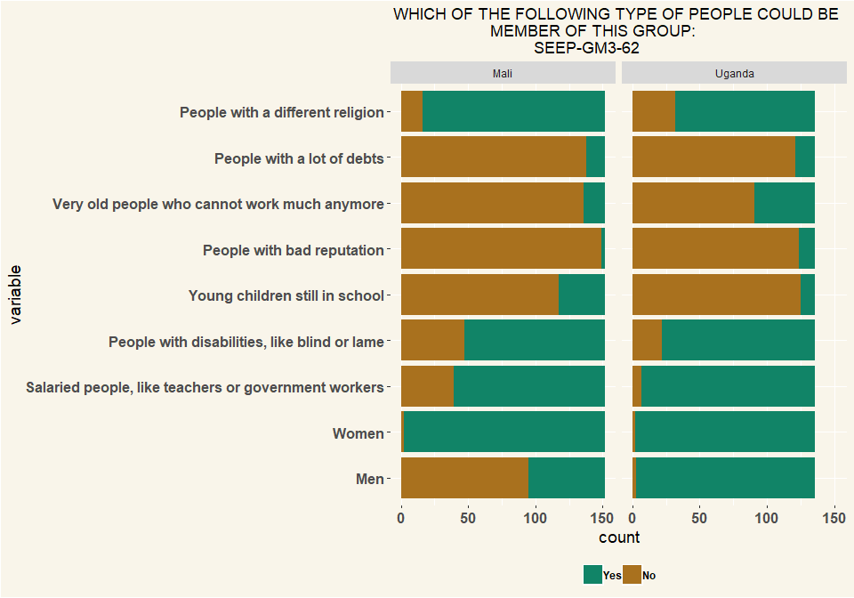

# Q63 What is the maximum number of members the group would agree to expand to?

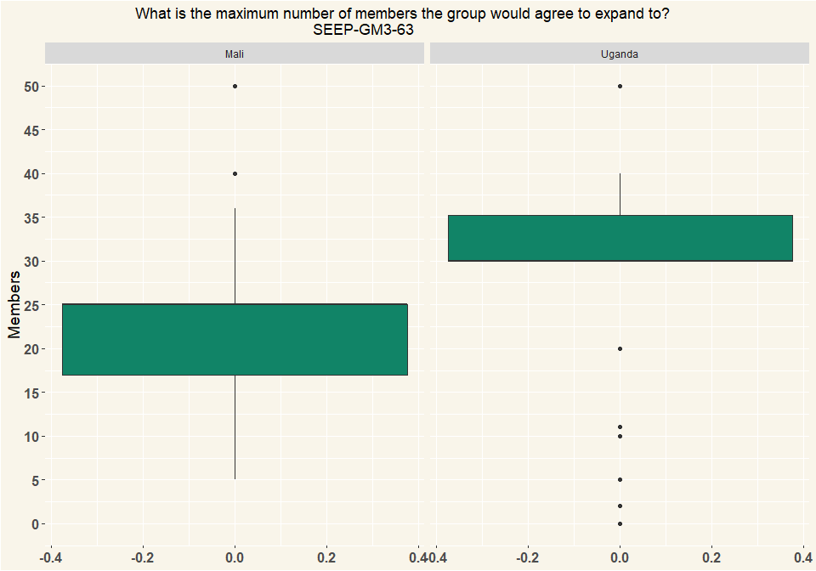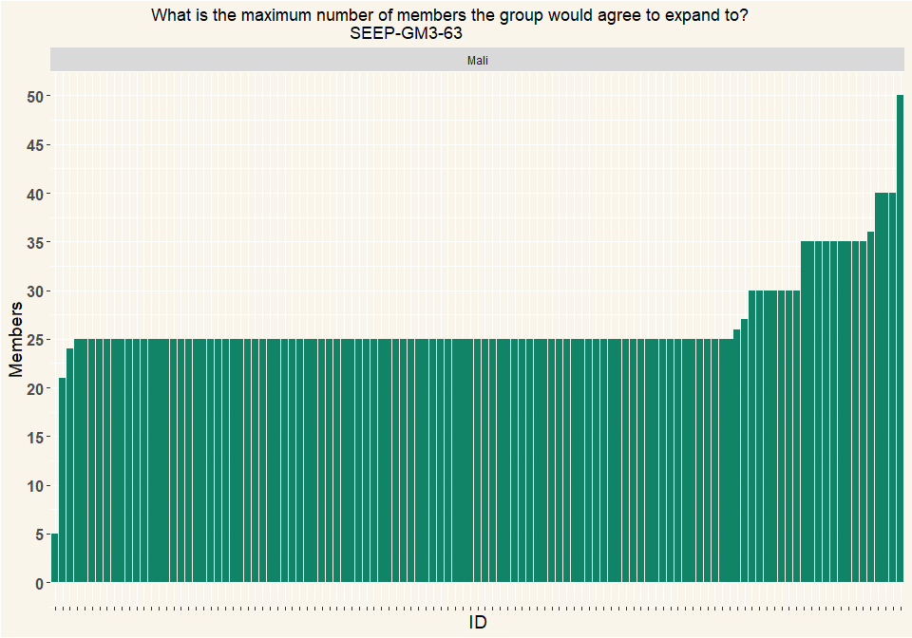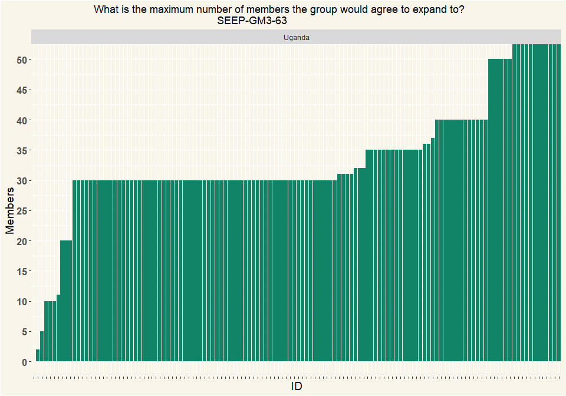

## # A tibble: 2 x 2  
## # Groups: Country [2]  
## Country n  
## <chr> <int>  
## 1 Mali 115  
## 2 Uganda 130

# Q64 What types of records does the group have? (Multiple Selection)

|  |  |  |
| --- | --- | --- |
| variable | Mali | Uganda |
| Central ledger | 105 | 111 |
| Passbooks | 18 | 119 |
| Phone, tablet or computer | 0 | 0 |
| Other: | 29 | 4 |
| Respondents | 152 | 136 |

|  |  |  |
| --- | --- | --- |
| variable | Mali | Uganda |
| Central ledger | 0.691 | 0.474 |
| Passbooks | 0.118 | 0.509 |
| Phone, tablet or computer | 0 | 0 |
| Other: | 0.191 | 0.0171 |
| Percentage | 1 | 1 |

# Q66 What is recorded? (Multiple Selection)

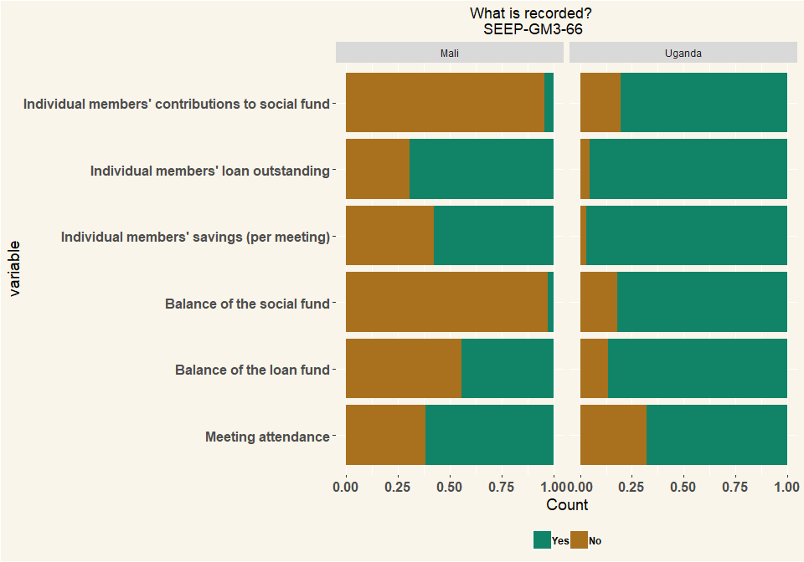

## # A tibble: 2 x 2  
## # Groups: Country [2]  
## Country n  
## <chr> <int>  
## 1 Mali 152  
## 2 Uganda 136

# 67 Is it possible to determine by simply looking at the records:

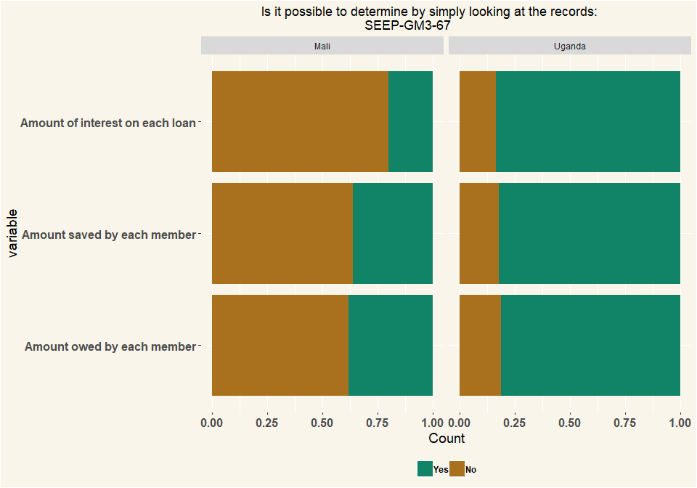

## # A tibble: 2 x 2  
## # Groups: Country [2]  
## Country n  
## <chr> <int>  
## 1 Mali 152  
## 2 Uganda 136

# Q68 Who keeps the passbooks between meetings?

|  |  |  |
| --- | --- | --- |
| value | Mali | Uganda |
| Members themselves keep it | 18 | 17 |
| Kept in the box or bag for money | 1 | 99 |
| Other place (specify) | 0 | 3 |
| Respondents | 19 | 119 |

|  |  |  |
| --- | --- | --- |
| value | Mali | Uganda |
| Members themselves keep it | 0.947 | 0.143 |
| Kept in the box or bag for money | 0.0526 | 0.832 |
| Other place (specify) | 0 | 0.0252 |
| Percentage | 1 | 1 |

# Q69 Did any person at the group-meeting spot any errors in the bookkeeping, from this week or previous meetings

|  |  |  |
| --- | --- | --- |
| value | Mali | Uganda |
| Yes | 1 | 6 |
| No | 151 | 130 |
| NA | 152 | 136 |

|  |  |  |
| --- | --- | --- |
| value | Mali | Uganda |
| Yes | 0.00658 | 0.0441 |
| No | 0.993 | 0.956 |
| NA | 1 | 1 |

# Q70 please describe the errors that you found?

|  |  |
| --- | --- |
| Others | n |
| addition of money | 1 |
| incorect loan disbursements | 1 |
| no error | 2 |
| no errors | 1 |
| none | 1 |
| not writing down some members loan repayment amounts | 1 |
| quelqu’un était resté debout aucour de la réunion est une erreur | 1 |
| some members are not accounted for their loans like not recognized as loan therefore,they spent like two months without paying interests for the loans they took | 1 |
| there was cash recorded not received | 1 |
| this a passbook where by they were supposed to put one stumb but they put two insteady | 1 |
| three weeks without stamping | 1 |

# Q71 Did you spot any errors in the bookkeeping when you looked at the records?

|  |  |  |
| --- | --- | --- |
| value | Mali | Uganda |
| Yes | 18 | 6 |
| No | 134 | 130 |
| Respondents | 152 | 136 |

|  |  |  |
| --- | --- | --- |
| value | Mali | Uganda |
| Yes | 0.118 | 0.0441 |
| No | 0.882 | 0.956 |
| Percentage | 1 | 1 |

# Q72 How often does your group meet?

|  |  |  |
| --- | --- | --- |
| value | Mali | Uganda |
| Daily | 24 | 14 |
| Weekly | 128 | 121 |
| Every 2 weeks | 0 | 1 |
| Respondents | 152 | 136 |

|  |  |  |
| --- | --- | --- |
| value | Mali | Uganda |
| Daily | 0.158 | 0.103 |
| Weekly | 0.842 | 0.89 |
| Every 2 weeks | 0 | 0.00735 |
| Percentage | 1 | 1 |

# Q73 Does your group have loan meetings and meetings where no loans are given (savings meetings)?

|  |  |  |
| --- | --- | --- |
| value | Mali | Uganda |
| Yes, only in some meetings can you get a loan,all meetings do savings | 24 | 14 |
| No, in all meetings we do both savings and loans | 128 | 121 |
| Other (specify) | 0 | 1 |
| Respondents | 152 | 136 |

|  |  |  |
| --- | --- | --- |
| value | Mali | Uganda |
| Yes, only in some meetings can you get a loan,all meetings do savings | 0.158 | 0.103 |
| No, in all meetings we do both savings and loans | 0.842 | 0.89 |
| Other (specify) | 0 | 0.00735 |
| Percentage | 1 | 1 |

# Q74 How long does a group meeting typically last? (Mutiple Selection)

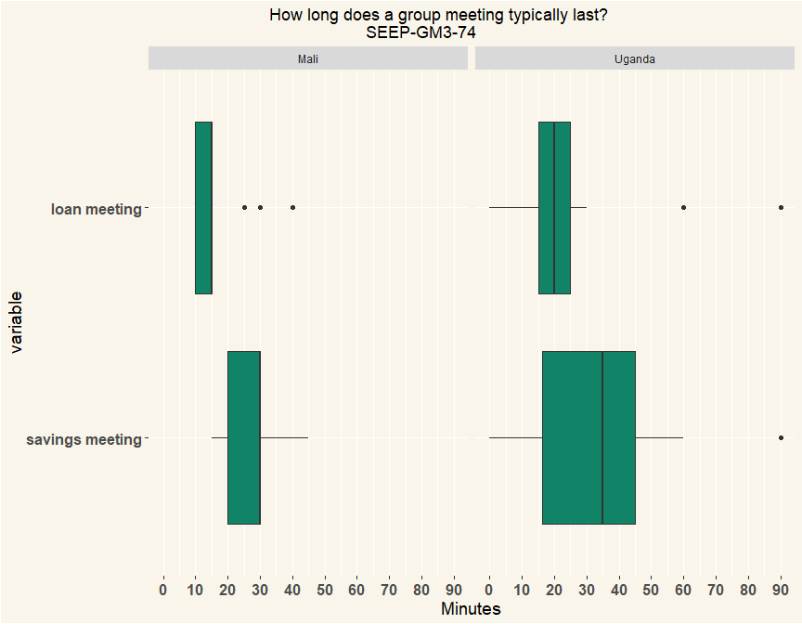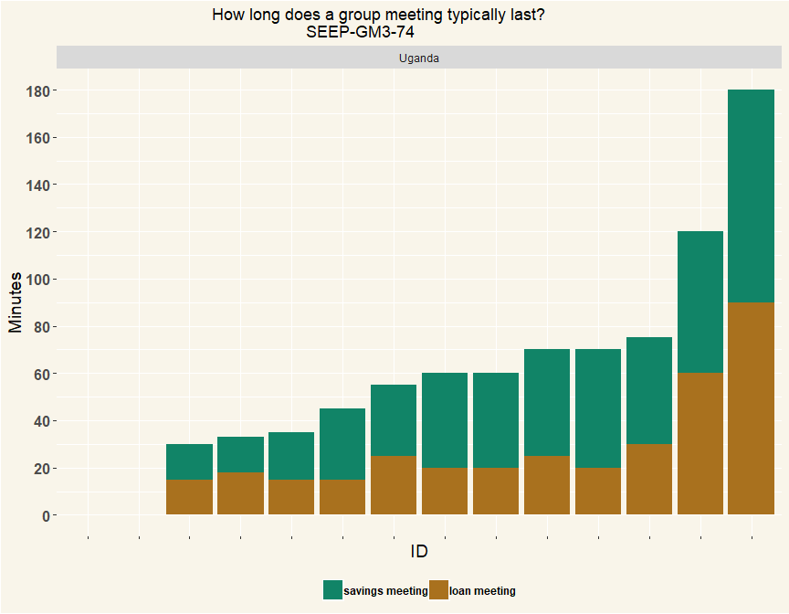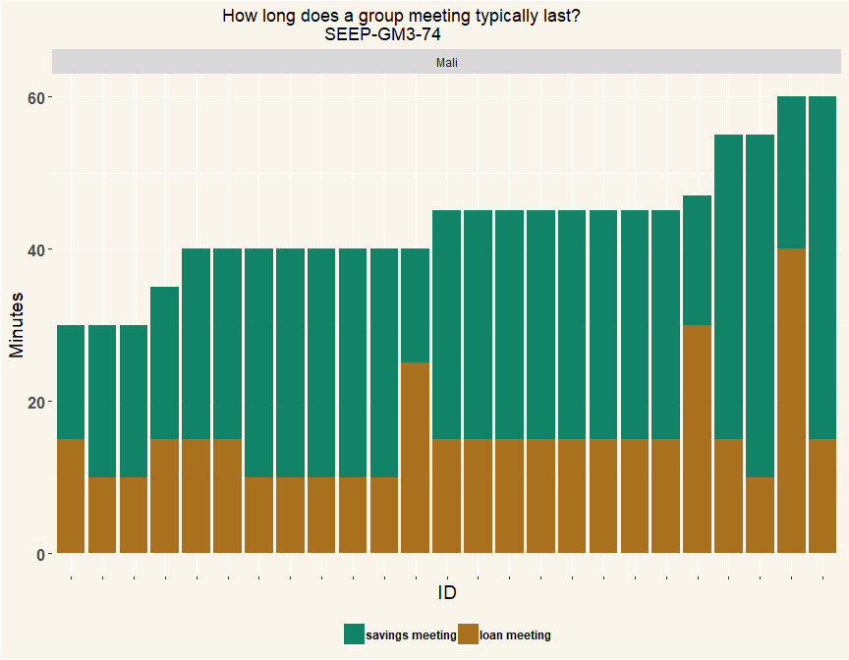

|  |  |
| --- | --- |
| Country | n |
| Mali | 25 |
| Uganda | 14 |

# 75 How long does a group meeting typically last?

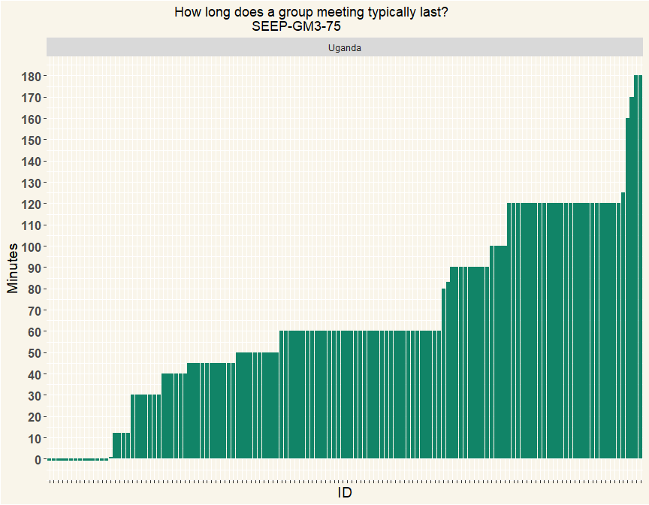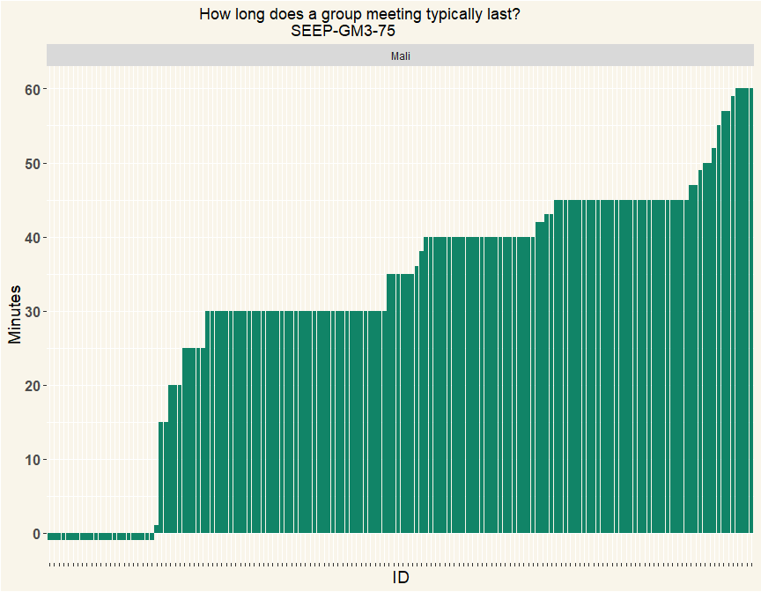

# 76 Does your group periodically distribute - or share out - its funds among the members?

|  |  |  |
| --- | --- | --- |
| Q_76 | Mali | Uganda |
| Yes, we share out (some or all) | 78 | 125 |
| No, we dont share out | 69 | 2 |
| I don’t know | 5 | 9 |
| Respondents | 152 | 136 |

|  |  |  |
| --- | --- | --- |
| Q_76 | Mali | Uganda |
| Yes, we share out (some or all) | 0.513 | 0.919 |
| No, we dont share out | 0.454 | 0.0147 |
| I don’t know | 0.0329 | 0.0662 |
| Percentage | 1 | 1 |

# 77 How many share outs do you remember?

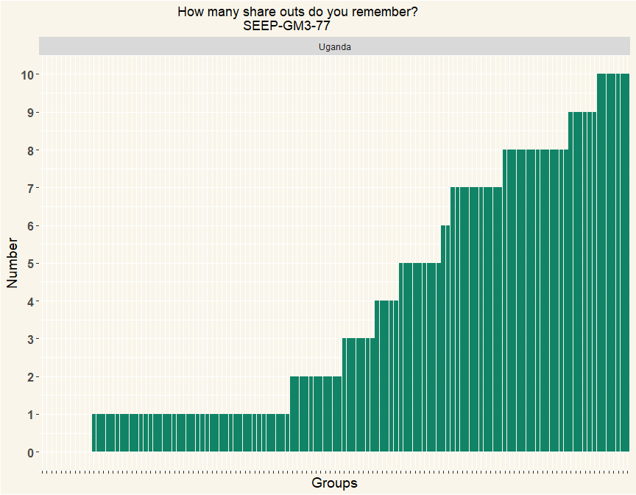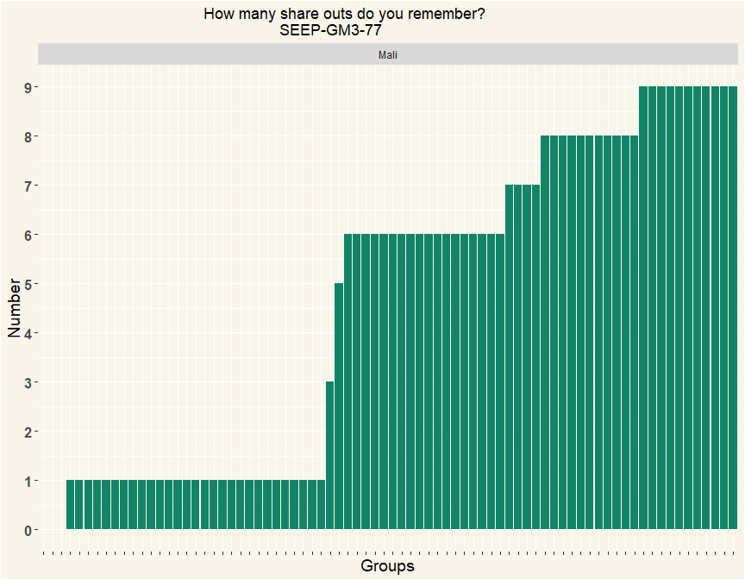

# 78 When was the most recent share out?

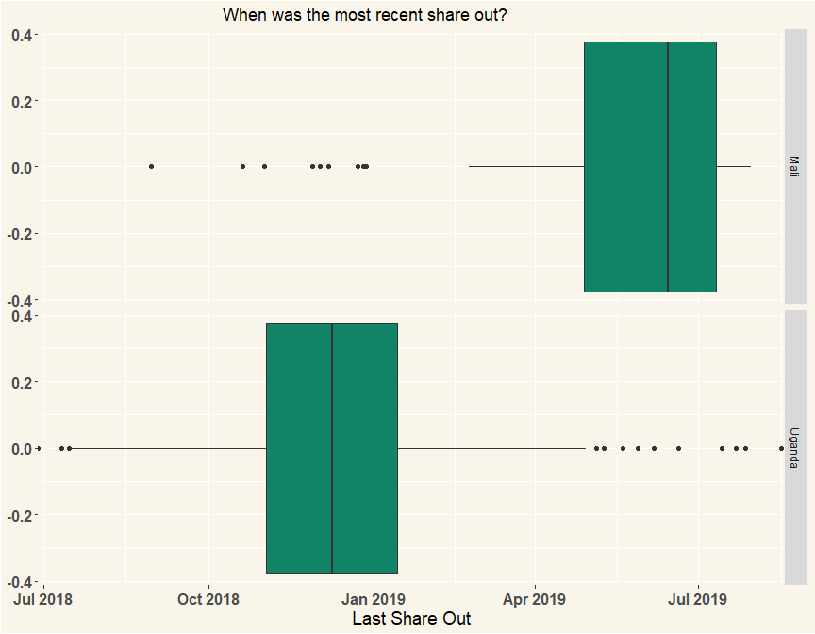

## # A tibble: 2 x 2  
## # Groups: Country [2]  
## Country n  
## <chr> <int>  
## 1 Mali 53  
## 2 Uganda 113

# 79 What was the total amount of the last share out?

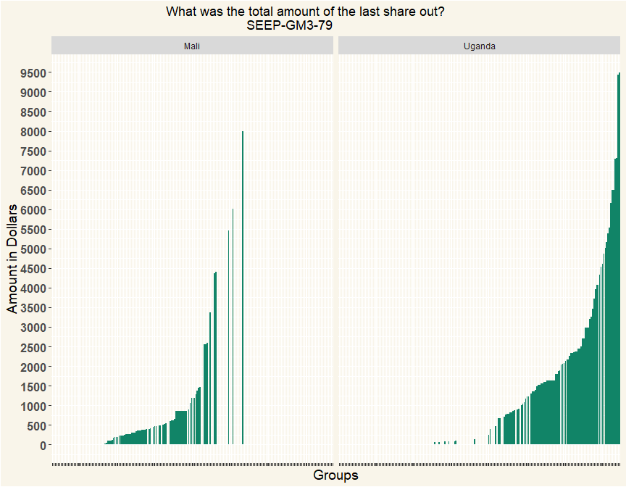

|  |  |
| --- | --- |
| Country | n |
| Mali | 78 |
| Uganda | 120 |

# 80 How many members participated in the share out?

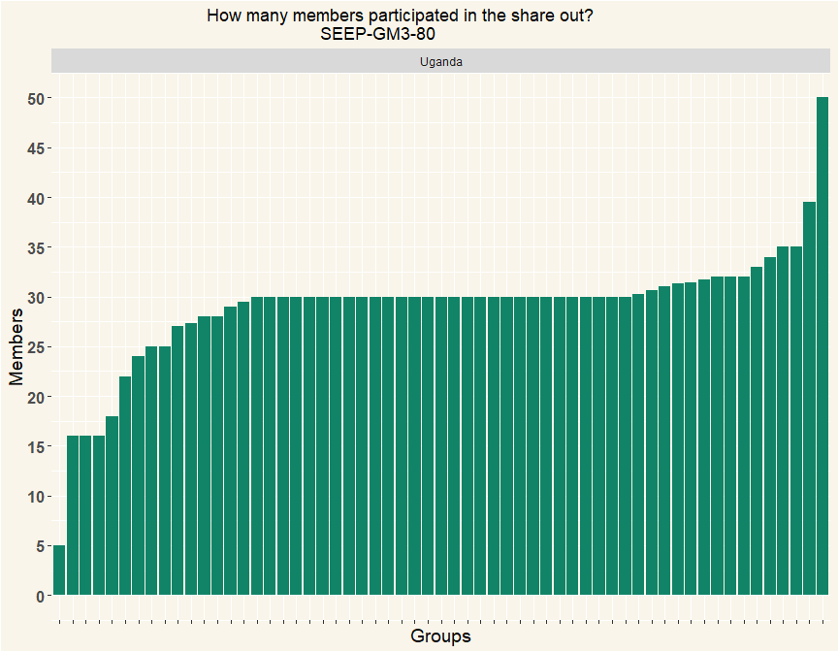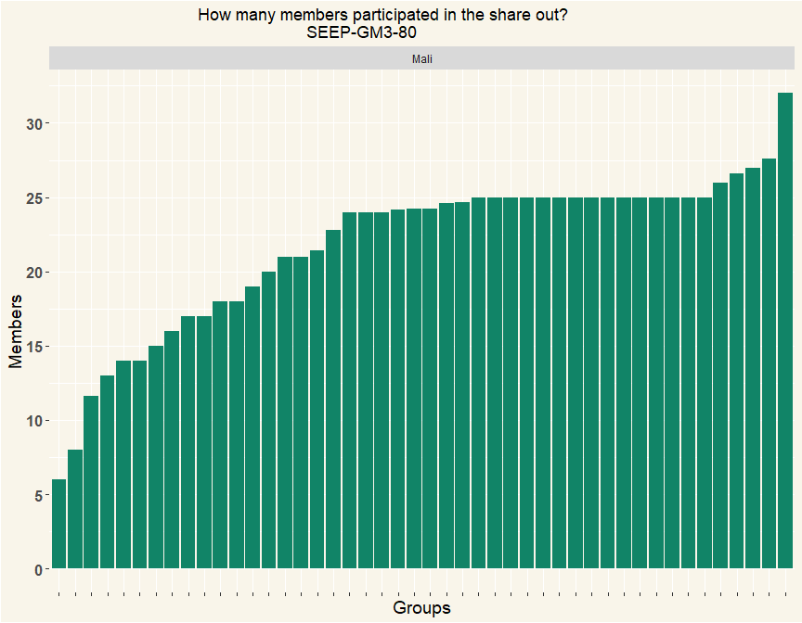

|  |  |
| --- | --- |
| Country | n |
| Mali | 46 |
| Uganda | 59 |

# 81 Were there any members who could not repay all their loans at share out?

|  |  |  |
| --- | --- | --- |
| value | Mali | Uganda |
| Yes | 1 | 16 |
| No | 45 | 42 |
| Dont Know | 0 | 1 |
| Respondents | 46 | 59 |

|  |  |  |
| --- | --- | --- |
| value | Mali | Uganda |
| Yes | 0.0217 | 0.271 |
| No | 0.978 | 0.712 |
| Dont Know | 0 | 0.0169 |
| Percentage | 1 | 1 |

# 82 How much was not paid back?

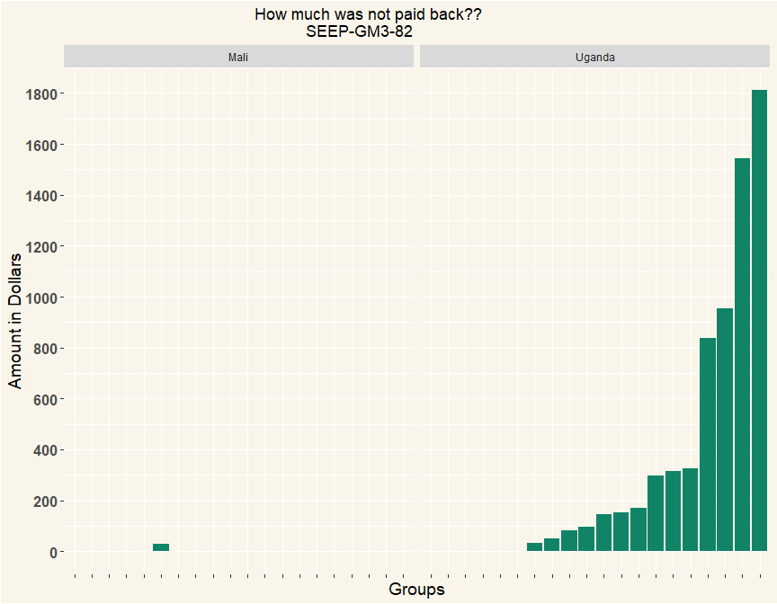

|  |  |
| --- | --- |
| Country | n |
| Mali | 1 |
| Uganda | 19 |

# 83 What happened? Could the group resolve the issue and if so, how?

|  |  |
| --- | --- |
| value | n |
| an individual who has loan gets loan from bank and pay loan of the group | 1 |
| forgive | 1 |
| forgot | 1 |
| forguven | 1 |
| group decided to count all they owe her and loan so she had zero balance | 1 |
| le groupe déduisent à leurs avoir l’ordre de partage de la fin du cycle. | 1 |
| Nothing was done, members disappeared | 1 |
| repayments of their loan by replacement os their savings | 1 |
| she separated from her husband and went away , we shared losses equally like one was taken away his sharing that is 8500 | 1 |
| Some were removed from the group. | 1 |
| The paid after share out | 1 |
| they could pay later after getting money after share out | 1 |
| they could replace it with savings.they pay the remaining one | 1 |
| They paid in this cycle | 1 |
| They promised to pay after one month but haven’t yet paid | 1 |
| they ran away from the village | 1 |
| We expelled them | 1 |
| We expelled those members | 1 |
| we kept on demanding and he paid some and wehad 200,000as write off | 1 |
| y | 1 |
| yes | 1 |
| yes by accounting their savings they minus loans | 1 |
| yes they could get loan from bank they clear saving group | 1 |
| yes,they only count total savings and total loan so their savings pay that loan | 1 |

# 84 Thank you. Then, the share out before that one – can you remember it? What was the date? Don’t know

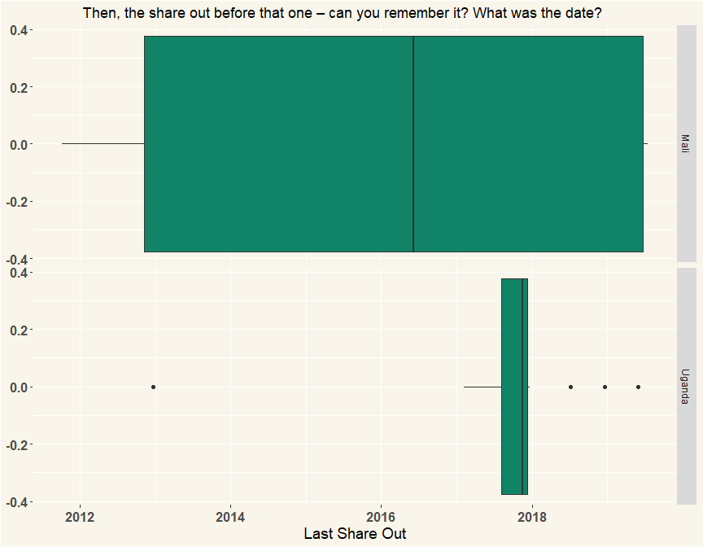

## # A tibble: 2 x 2  
## # Groups: Country [2]  
## Country n  
## <chr> <int>  
## 1 Mali 44  
## 2 Uganda 30

# Q85 What are other opportunities motivations for joining SFC (Uganda: VSLA) group apart from savings? (Multiple Selection)

|  |  |  |
| --- | --- | --- |
| variable | Mali | Uganda |
| Social/being with friends | 143 | 106 |
| Learning skills | 81 | 106 |
| Organizing women to be strong together | 79 | 66 |
| Possibility to get loan | 86 | 97 |
| Possibility to do a business as a group | 75 | 38 |
| Selling goods to others | 27 | 17 |
| Other (specify) | 0 | 6 |
| Respondents | 152 | 136 |

|  |  |  |
| --- | --- | --- |
| variable | Mali | Uganda |
| Social/being with friends | 0.291 | 0.243 |
| Learning skills | 0.165 | 0.243 |
| Organizing women to be strong together | 0.161 | 0.151 |
| Possibility to get loan | 0.175 | 0.222 |
| Possibility to do a business as a group | 0.153 | 0.0872 |
| Selling goods to others | 0.055 | 0.039 |
| Other (specify) | 0 | 0.0138 |
| Percentage | 1 | 1 |

# Q86 How have members livelihood changed as a result of being an SFC (Uganda VSLA) member? How? (Multiple Selection)

|  |  |  |
| --- | --- | --- |
| variable | Mali | Uganda |
| They have more income | 130 | 114 |
| They have less income | 10 | 8 |
| They have more possessions | 101 | 68 |
| They have less possessions | 5 | 3 |
| They have more businesses | 78 | 44 |
| They have less businesses | 11 | 6 |
| They have smoother finances | 97 | 55 |
| They have more spiky finances | 17 | 2 |
| Other (specify) | 1 | 6 |
| Respondents | 152 | 136 |

|  |  |  |
| --- | --- | --- |
| variable | Mali | Uganda |
| They have more income | 0.289 | 0.373 |
| They have less income | 0.0222 | 0.0261 |
| They have more possessions | 0.224 | 0.222 |
| They have less possessions | 0.0111 | 0.0098 |
| They have more businesses | 0.173 | 0.144 |
| They have less businesses | 0.0244 | 0.0196 |
| They have smoother finances | 0.216 | 0.18 |
| They have more spiky finances | 0.0378 | 0.00654 |
| Other (specify) | 0.00222 | 0.0196 |
| Percentage | 1 | 1 |

# Q87 Are VSLAs used as a platform for other interventions in the communities? What are they? (Multiple Selection)

|  |  |  |
| --- | --- | --- |
| variable | Mali | Uganda |
| For selling/buying to each other | 105 | 49 |
| For selling in bulk | 59 | 17 |
| For joint business | 65 | 30 |
| For learning economic skills | 97 | 82 |
| For learning about nutritioin | 59 | 29 |
| For learning about health | 58 | 41 |
| For learning about finance | 87 | 67 |
| For organizing politically | 49 | 26 |
| For fighting for women’s rights | 62 | 28 |
| Other (specify) | 1 | 6 |
| Respondents | 152 | 136 |

|  |  |  |
| --- | --- | --- |
| variable | Mali | Uganda |
| For selling/buying to each other | 0.164 | 0.131 |
| For selling in bulk | 0.0919 | 0.0453 |
| For joint business | 0.101 | 0.08 |
| For learning economic skills | 0.151 | 0.219 |
| For learning about nutritioin | 0.0919 | 0.0773 |
| For learning about health | 0.0903 | 0.109 |
| For learning about finance | 0.136 | 0.179 |
| For organizing politically | 0.0763 | 0.0693 |
| For fighting for women’s rights | 0.0966 | 0.0747 |
| Other (specify) | 0.00156 | 0.016 |
| Percentage | 1 | 1 |

# Q88 How does to the community view members of SFC (Uganda: VSLA)?

|  |  |
| --- | --- |
| Q_88 | n |
| active members in the community | 1 |
| appréciation des membres du groupe par la communauté | 5 |
| as a main source of school fees | 1 |
| as creative people | 1 |
| as economically active members | 1 |
| as group which saves alot and many people community | 1 |
| as members who are active and | 1 |
| as members who are economically powerfull | 1 |
| as organised and people who are united | 1 |
| as strong group | 1 |
| as strong people | 1 |
| as the saving group which has god,coperation and love | 1 |
| as very active and inovative people | 1 |
| assez bien | 1 |
| bein | 1 |
| bie | 1 |
| bien | 5 |
| bien perçu | 2 |
| bien vu par certain et condamné par d’autre | 1 |
| bien vu par certain mal vu vue par d’autre | 1 |
| bien vu par l’autre et contraires pour d autre | 1 |
| bonne | 3 |
| bonne initiative | 1 |
| by voting | 1 |
| c’est les femmes bonnes | 1 |
| comme des bonnes initiative | 1 |
| comme quelques choses de tres intéressante | 1 |
| committed women and men | 1 |
| des battante | 1 |
| des compétence sur l’economi | 1 |
| des femmes battante | 2 |
| des femmes battante et courageuses | 1 |
| des femmes leader | 1 |
| des héros | 2 |
| des tres intéressante initiative | 1 |
| developed group | 1 |
| developmental | 2 |
| elle les trouve tres impressionnante | 1 |
| encouragement des membres de l’epc par la communauté | 2 |
| encouragement des membres du groupe par la communauté | 6 |
| encouragement des membres par la communauté | 4 |
| encouragent des groupes epc par les communautés | 1 |
| g | 1 |
| giving them training | 1 |
| goal oriented group | 1 |
| good | 1 |
| good in | 1 |
| h | 1 |
| hard | 3 |
| hard working | 4 |
| i cant tell what people talk about it. | 1 |
| i do not know. | 1 |
| i don’t know. | 1 |
| i don’t know. | 2 |
| i really don’t know | 1 |
| il sont bien perçu | 1 |
| impressionnant | 1 |
| it connects people | 1 |
| it has benefited them much | 1 |
| it has changed the income status of women | 1 |
| it has empowered women and women have been hardworking | 1 |
| it has helped members to grow and made them work hard | 1 |
| it helped women to have their own money | 1 |
| it is a hard working group | 1 |
| it is disciplined group and it has empowered women | 1 |
| its easily accessible in most villages. | 1 |
| its normal since most members belong to the vsla | 1 |
| je ne saiq pa | 1 |
| je sais pas | 2 |
| jj | 1 |
| just like other members of the community who are more active financially | 1 |
| l’appréciation des membres du groupe par la communauté | 1 |
| la communauté encouragent les membres de l’epc | 1 |
| la porte de développement durable du village | 1 |
| le est encouragé et apprécié par la communauté | 1 |
| le groupe d’épargne est un bon projet | 1 |
| learning new skills | 1 |
| les communautés encouragent les membres du groupe epc ,car à causes de leur groupements on trouve l’argent à prêter | 1 |
| les femmes courageux et battante | 1 |
| les femmes riche | 1 |
| les femmes sont des battante | 2 |
| les gens n’ont pas appréciés par ce qu’elles n’intéressent pas a teguérèné | 1 |
| les gens ont appréciés | 1 |
| les gens ont appréciés beaucoup | 2 |
| les gens ont beaucoup appréciés | 1 |
| les gens ont bien appréciés | 1 |
| les gens ont biens appréciés | 1 |
| les gens sont beaucoup appréciés | 1 |
| les groupes d’épargne pour le changement sont bien perçu par la communauté | 1 |
| les membres du groupe epc sont solidaires | 1 |
| les membres epc sont bie. perçu par la communauté | 1 |
| les villageois n’apprécient pas beaucoup par ce que certaines personnes n’aiment pas la solidarité | 1 |
| les villageois nous ont bien apprécié | 1 |
| les villageois ont bien apprécié | 1 |
| les villageois ont bien appréciés | 8 |
| les villageois ont bien appréciés que soit hommes et femmes | 1 |
| members are trustworthy | 1 |
| members get attracted and feel like joining the group too | 1 |
| members that work together | 1 |
| members view us as active people in the community | 1 |
| members who are active and developmental | 1 |
| money maker | 2 |
| most active women | 1 |
| much organized group | 1 |
| none | 1 |
| nous des héros du village | 1 |
| nous sommes des amazones aux yeux des hommes de kadiana | 1 |
| nous sommes des femmes battante et courageux | 1 |
| nous sommes des femmes courageux malgré tout ce ils disent nous n’avons pas abandonne | 1 |
| nous sommes sollicités et appuyées par les hommes du village | 1 |
| ont s’intéresse pas aux pensées d’autrui mais la création des groupes font de nous des héros | 1 |
| organised members | 1 |
| other community wish to be with us | 1 |
| other people wished to be among us so us becouse we behave well. | 1 |
| others like to join us | 1 |
| par certains ou mais pas par d autre | 1 |
| people admire us and call us blessed | 1 |
| people alwsys have different opinions others negative and others positive | 1 |
| people in the community say the savings group has no benefit to the people in it | 1 |
| people say this group has stayed long than other groups and admire to join to join it | 1 |
| people who are financially active and people who have money | 1 |
| positivement | 10 |
| positivement ,en bien | 2 |
| positivement, en bien | 2 |
| positivement,en bien | 16 |
| que c,est des tres bonne initiative | 1 |
| saving group has helped us in inreasing our income in our community | 1 |
| saving group which fights for womens rights | 1 |
| so helpful | 1 |
| social and admirable | 1 |
| some admire them | 1 |
| that our group is so good | 1 |
| the community looks at ladies as hardworking and people who are committed and work together | 1 |
| the community looks at members as people who have money since they save oftenly | 1 |
| the community love the group becouse it has many possessions | 1 |
| the community views members as committed and serious and members who are united | 1 |
| the community wished to be us | 1 |
| the feel like they should join and treasure us | 1 |
| the group has no conflicts | 1 |
| the group that has empowered women and women | 1 |
| there no conficts in this group | 1 |
| they admire me | 1 |
| they admire our group and say it has empowered women | 1 |
| they admire our working as a team and the developments that we have achieved | 1 |
| they admire them | 8 |
| they admire them so much | 1 |
| they are committed women | 1 |
| they are looked at as hard woeking members. | 1 |
| they are wel organised | 2 |
| they are welcome organised and they train them | 1 |
| they are well organised | 1 |
| they have become so strong and confidence to stand by their feet. | 1 |
| they have helped members so much about saving and working hard | 1 |
| they have no problem with it since most members in the village are in vsla | 1 |
| they look at them as productive people. | 1 |
| they organise women and train them | 2 |
| they organise women to get money | 1 |
| they say its a good plan | 1 |
| they take us to be more organized | 1 |
| they they don’t know | 1 |
| they think they are rich | 1 |
| they train people on finance management | 1 |
| they train women and give out money for business | 1 |
| they train women on development issue,and they give money to women | 1 |
| they train women saving culture | 1 |
| they view them as active members and productive. | 1 |
| they view them as hard-working people. | 1 |
| they view us as loving group | 1 |
| they wish to join | 1 |
| through meetings | 1 |
| très bonne | 10 |
| très bonne et positivement | 1 |
| tres bonne initiative | 1 |
| tres intéressante | 2 |
| une bonne initiative | 4 |
| une bonne initiative qui leurs aient permis davoir une compétence financière | 1 |
| une chose qui leurs aient permis de faire leur petit besoin facilement | 1 |
| une chose tres intéressante | 1 |
| une grande porte de développement du village | 1 |
| une tres bonne chose | 1 |
| une tres bonne initiative | 2 |
| une tres bonne initiative qui leurs aient de gérer leur petit besoin tres facilement | 1 |
| vary helpful because it has empowered women and helped them to work hard | 1 |
| very helpful | 3 |
| very important | 2 |
| very important for saving and borrowing | 1 |
| very interesting group | 1 |
| very organised group | 2 |
| vie. perçu mais pas par tout le monde | 1 |
| we are a coperated and trust worthy company | 1 |
| we don’t know | 1 |
| wel financally | 1 |
| well organised group | 2 |
| working together as ateam | 1 |

```